**Customer Churn Prediction**

**Problem Definition:** Churn rate is a critical metric of customer satisfaction. **Low churn rates mean happy customers; high churn rates mean customers are leaving you.**

**Customer retention can be achieved with good customer service and products. But the most effective way for a company to prevent attrition of customers is to truly know them. The vast volumes of data collected about customers can be used to build churn prediction models. Knowing who is most likely to defect means that a company can prioritise focused marketing efforts on that subset of their customer base.**

[According to Forbes](https://www.forbes.com/sites/jiawertz/2018/09/12/dont-spend-5-times-more-attracting-new-customers-nurture-the-existing-ones/?sh=badf6205a8e0), it takes a lot more money (up to five times more) to get new customers than to keep the ones you already have. Churn tells you how many existing customers are leaving your business, so lowering churn has a big positive impact on your revenue streams.

Preventing customer churn is critically important to the telecommunications sector, as the barriers to entry for switching services are so low.

**Type of Problem :**

In this problem, I have to predict Total charges paid by the customer, Because Customers who are more likely to drop any Telecom service provider, they use their minimum services or for the short duration or use only prepaid services. So here 'Target Column' is TotalCharges.Since this column has continuous data, so it is a Regression problem. I have used following algorithms to predict Customer Churn and found Random Forest Regressor gives best prediction with this dataset.

1. Linear Regression
2. Decision Tree Regressor
3. Random Forest Regressor
4. KNeighbors Regressor
5. Gradient Boosting Regressor

**Dataset Description:**

* CustomerID: Customer ID unique for each customer
* gender: Whether the customer is a male or a female
* SeniorCitizen: Whether the customer is a senior citizen or not (1, 0)
* Partner: Whether the customer has a partner or not (Yes, No)
* Dependents: Whether the customer has dependents or not (Yes, No)
* tenure: Number of months the customer has stayed with the company
* PhoneService: Whether the customer has a phone service or not (Yes, No)
* MultipeLines: Whether the customer has multiple lines or not (Yes, No, No phone service)
* InternetService: Customer’s internet service provider (DSL, Fiber optic, No)
* OnlineSecurity: Whether the customer has online security or not (Yes, No, No internet service)
* OnlineBackup: Whether the customer has an online backup or not (Yes, No, No internet service)
* DeviceProtection: Whether the customer has device protection or not (Yes, No, No internet service)
* TechSupport: Whether the customer has tech support or not (Yes, No, No internet service)
* StreamingTV: Whether the customer has streaming TV or not (Yes, No, No internet service)
* StreamingMovies: Whether the customer has streaming movies or not (Yes, No, No internet service)
* Contract: The contract term of the customer (Month-to-month, One year, Two years)
* PaperlessBilling: Whether the customer has opted for Paperless billing (Yes, No)
* PaymentMethod: The customer’s payment method (Electronic check, Mailed check, Bank transfer (automatic), Credit card (automatic))
* MonthlyCharges: The amount charged to the customer monthly
* TotalCharges: The total amount charged to the customer
* Churn: Whether the customer continue the service provided by Telecom company or not (Yes/No)

**Data Collection:**

Dataset is available at GitHub in dsrscientist repository. Data is taken from following link:

https://raw.githubusercontent.com/dsrscientist/DSData/master/Telecom_customer_churn.csv

**Importing libraries:**

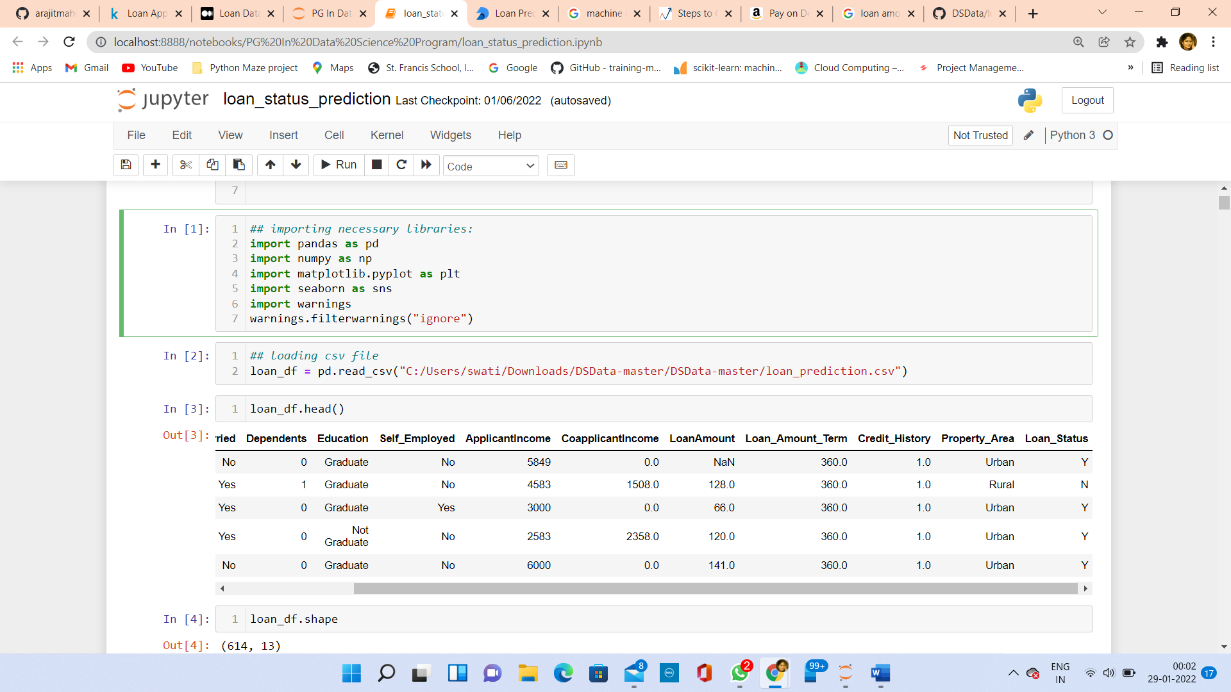

**Load Dataset:**

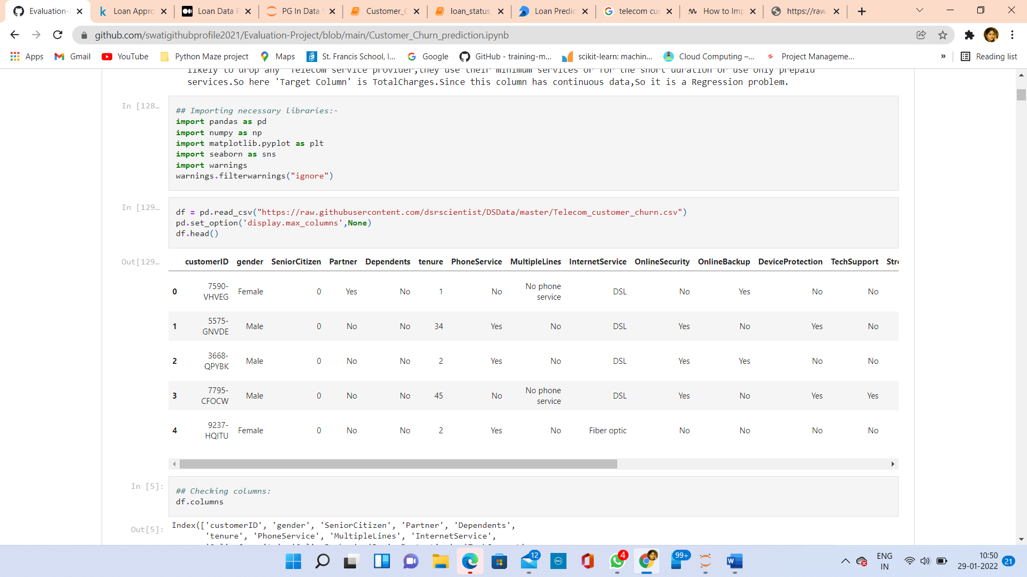

There are 7043 rows and 21 columns.

**Data Analysis**

**Data Types:**

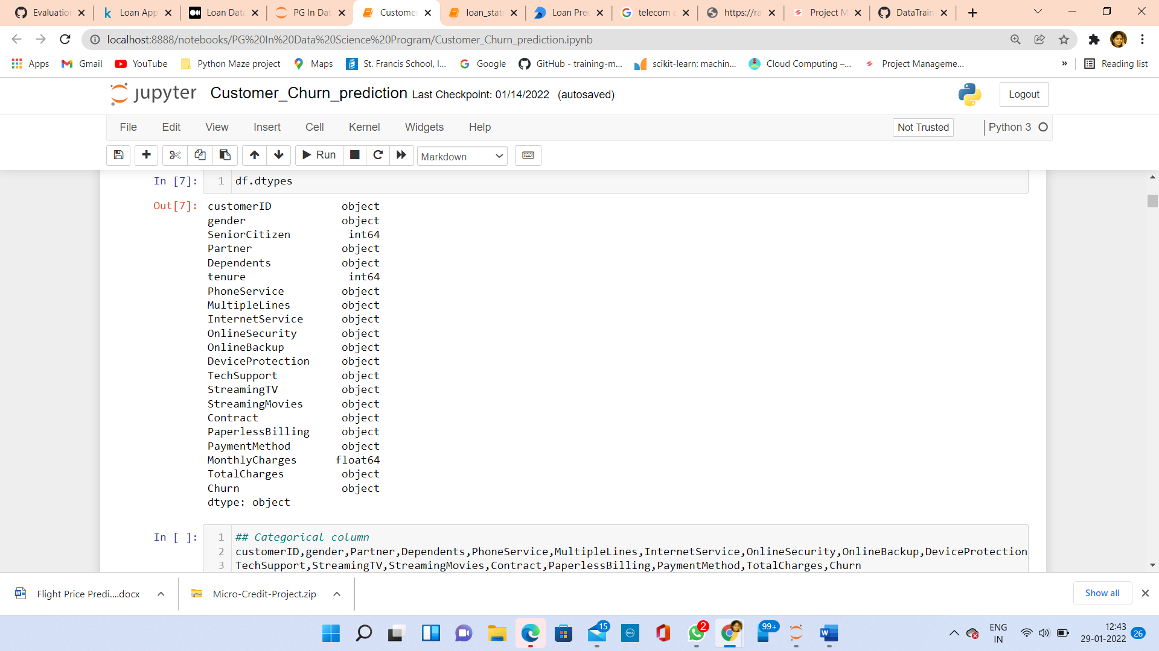

**Categorical column:**

customerID, gender, Partner, Dependents, PhoneService, MultipleLines, InternetService, OnlineSecurity, OnlineBackup, DeviceProtection, TechSupport, StreamingTV, StreamingMovies, Contract, PaperlessBilling, PaymentMethod, TotalCharges, Churn

**Numerical column**

SeniorCitizen, tenure, MonthlyCharges

**Checked unique values in each column by pandas value_counts () method and found following observations: -

* customerID has 7043 unique values.
* gender has 2 values Male and Female.
* SeniorCitizen has 2 values 0 and 1. Partner, Dependents, PhoneService, Churn, PaperlessBilling columns have 2 values, Yes or No.
* MultipleLines has 3 values No, Yes, and No Phone Service. InternetService has 3 values Fiber optic, DSL and No. OnlineSecurity,
* OnlineBackup, DeviceProtection, TechSupport, StreamingTV, StreamingMovies have 3 values No, yes, and No internet service.
* Contract has 3 values: - Month-to-month, Two year and One Year.
* PaymentMethod has 4 types of values: Electronic check, Mailed check, Bank transfer (automatic), Credit card (automatic)
* **TotalCharges has 6531 values.

*** I have seen from value_counts method, there are 11 values of blank space or white space in TotalCharges column.

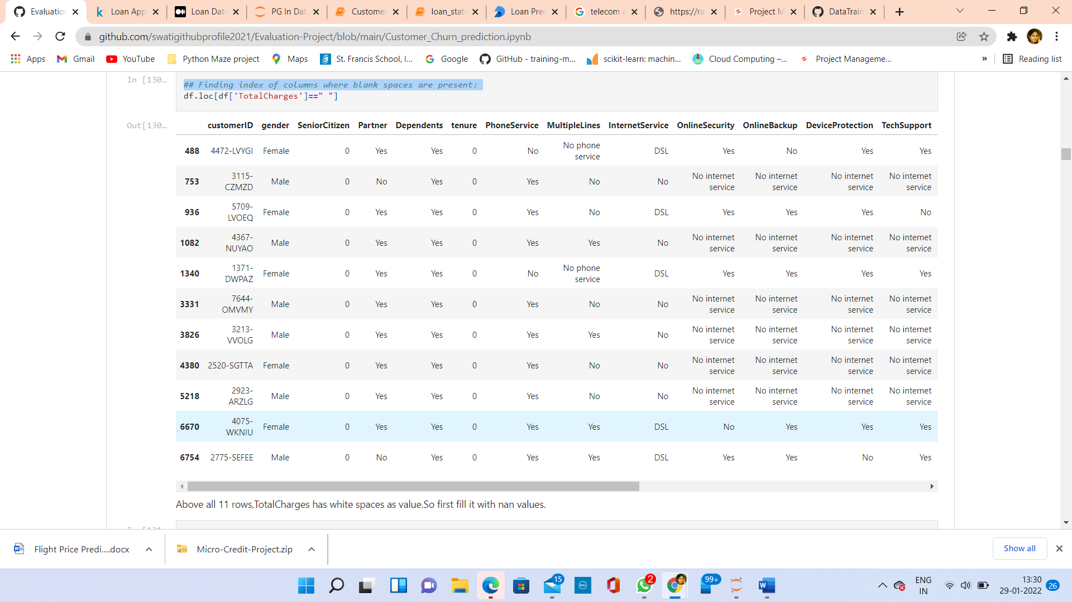

Filling blank spaces with nan values

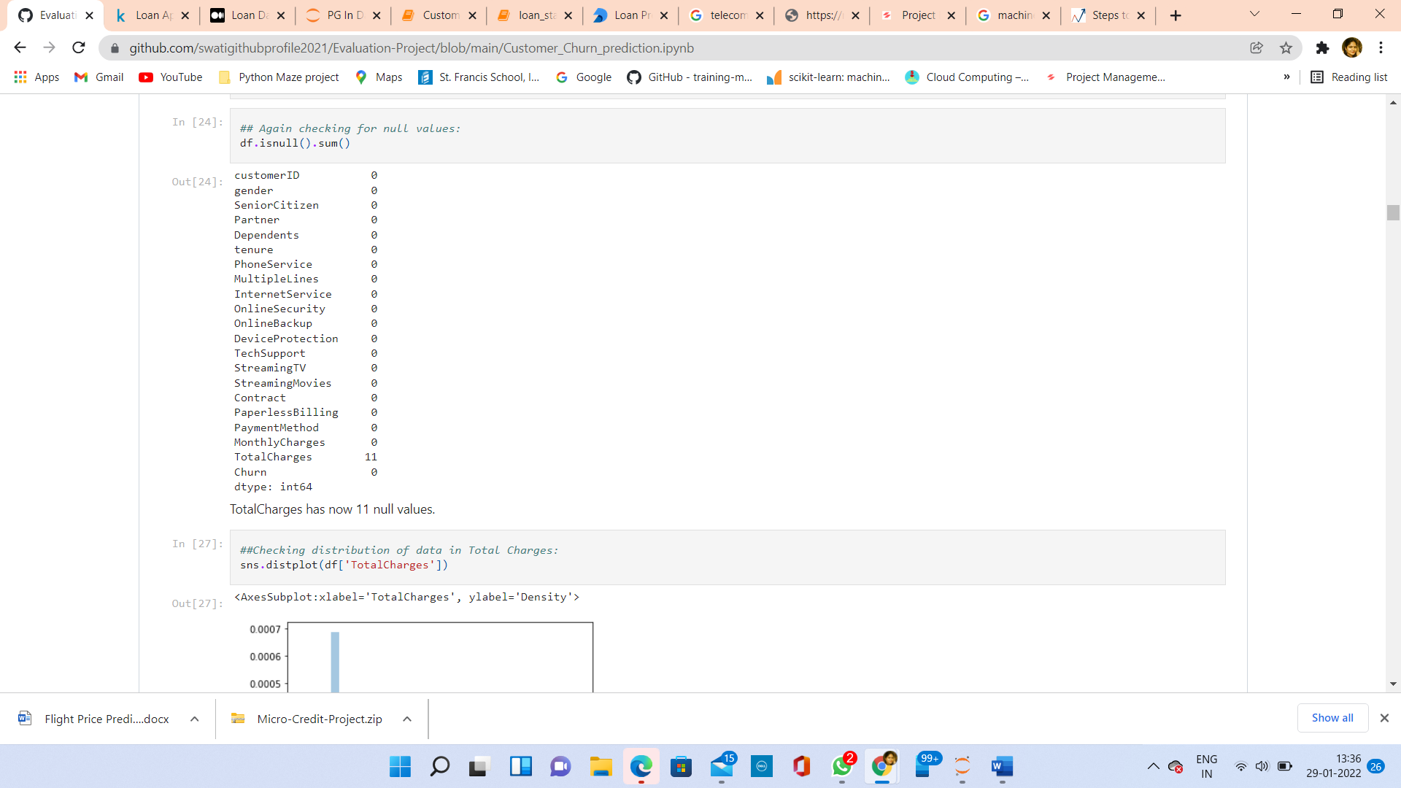

Checked data distribution in TotalCharges column and found data is not very much skewed,

So, I replaced null values with mean. Following are the process step by step:-

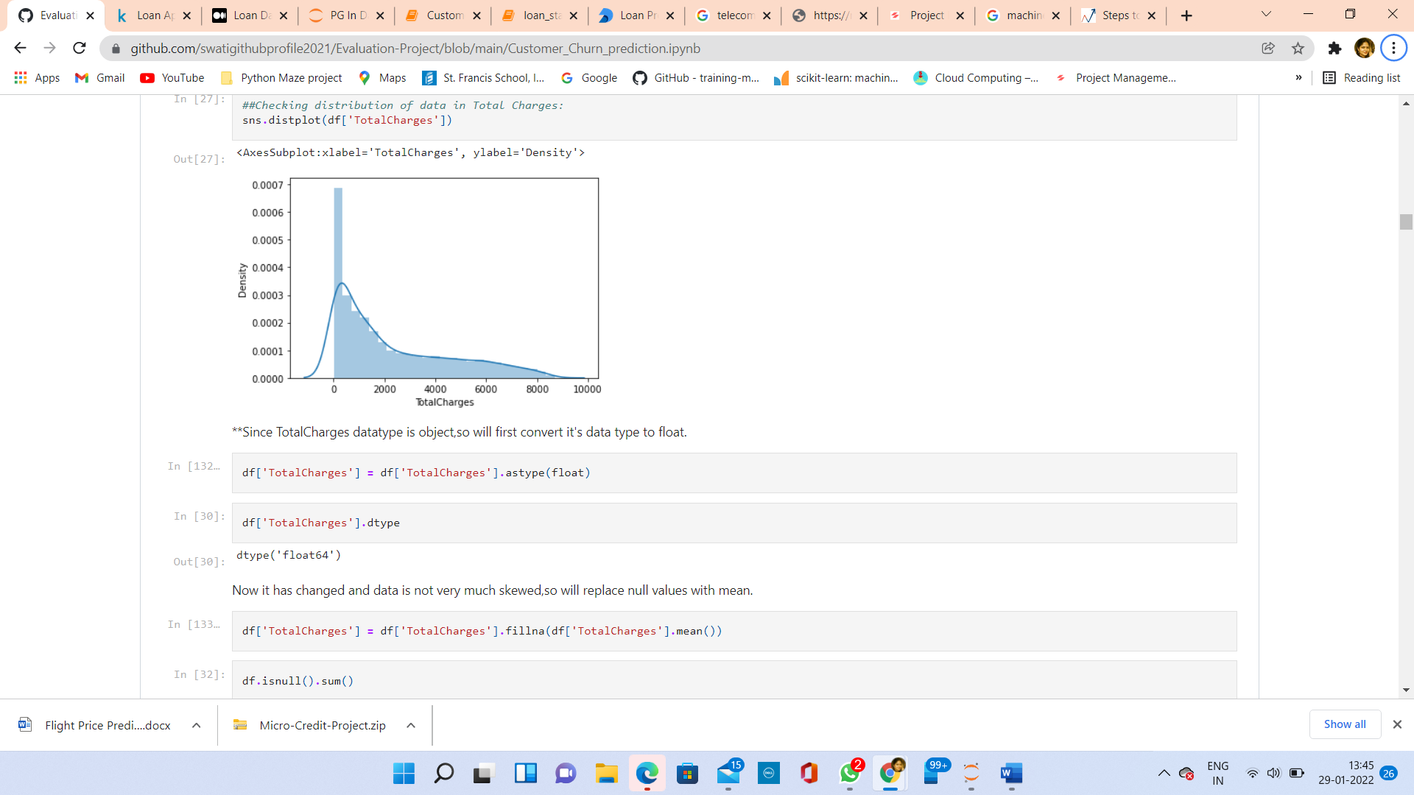

Again, checked for null values and found not any null values present

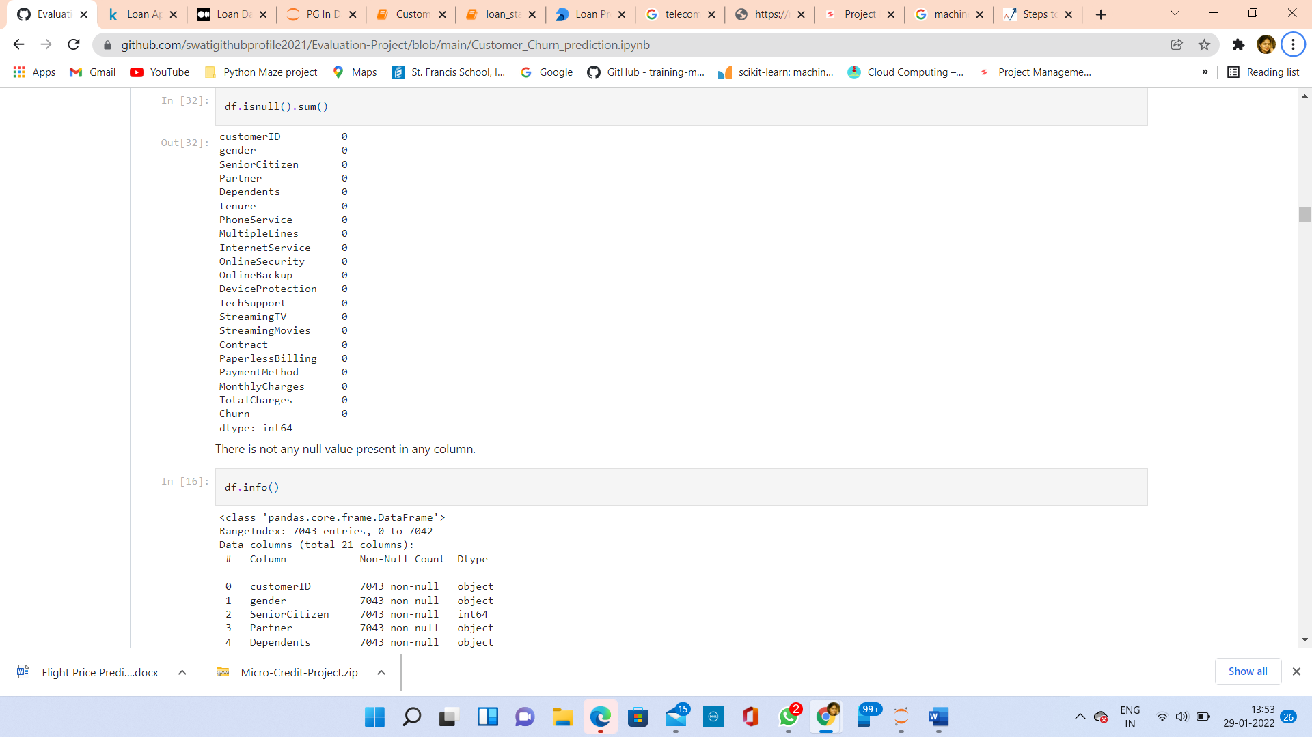

**EDA(Exploratory Data Analysis):**

EDA is the first step in the process of data analysis. Let us see the summary of the dataset. The info() method in the pandas library gives us the summary of the dataset.

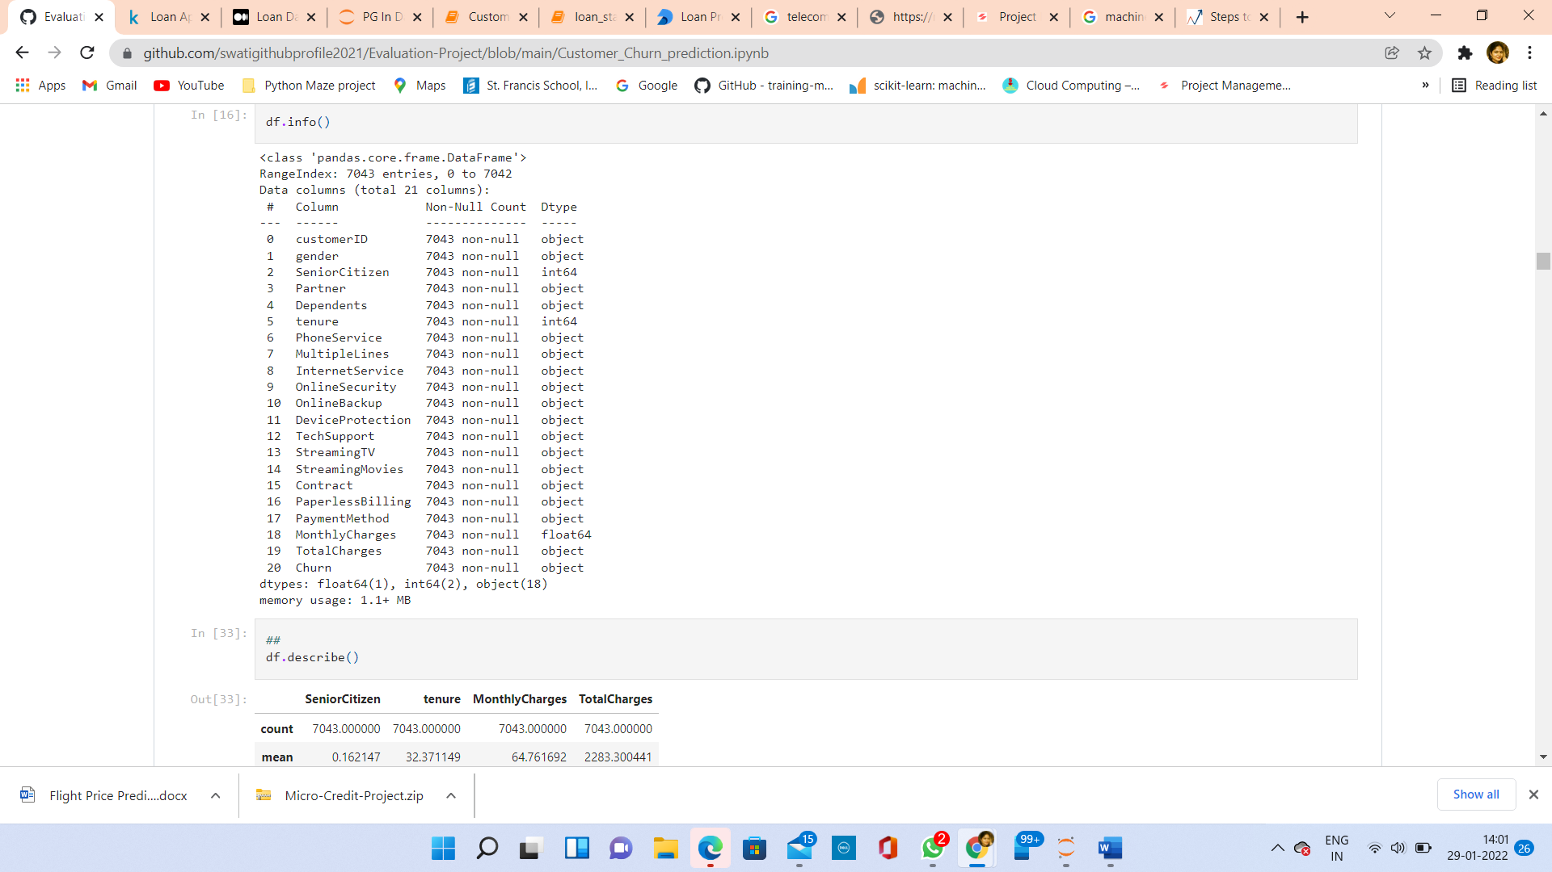

There is not any null value present in dataset.

**Description of the Dataset:**

Describe method with default parameters gives statistics only for continuous data.

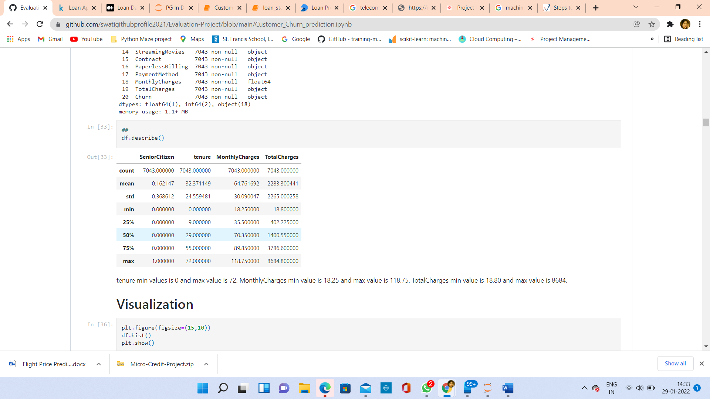

**Observations from Describe() method:**

* tenure min value is 0 and max value is 72.
* MonthlyCharges min value is 18.25 and max value is 118.75.
* TotalCharges min value is 18.80 and max value is 8684.

**Data Visualization:**

Histogram for continuous data:

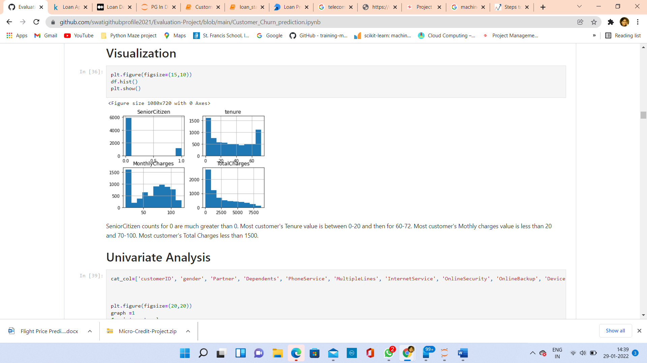

**Observations from Histplot:**

* SeniorCitizen counts for 0 are much greater than 0.
* Most customer's Tenure value is between 0-20 and then for 60-72.
* Most customer's Monthly charges value is less than 20 and 70-100.
* Most customer's Total Charges less than 1500.

**Univariate Analysis**

Univariate analysis is the simplest form of data analysis where the data being analysed contains only one variable. Since it's a single variable it doesn't deal with causes or relationships.

Let’s visualize categorical columns using countplot :

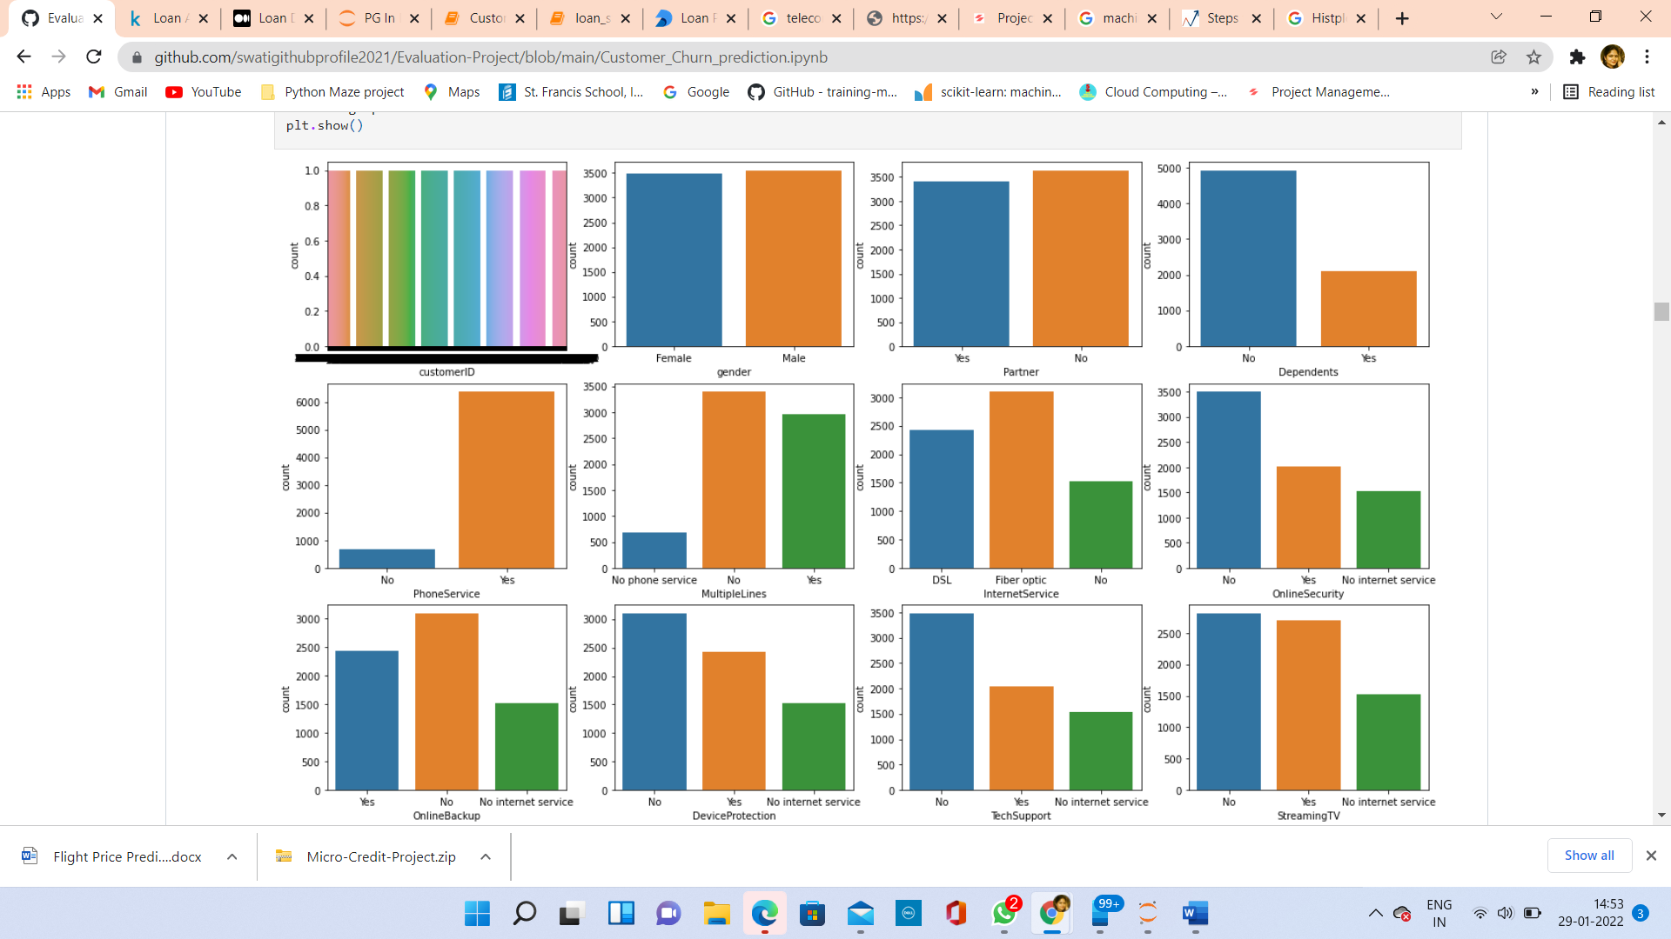

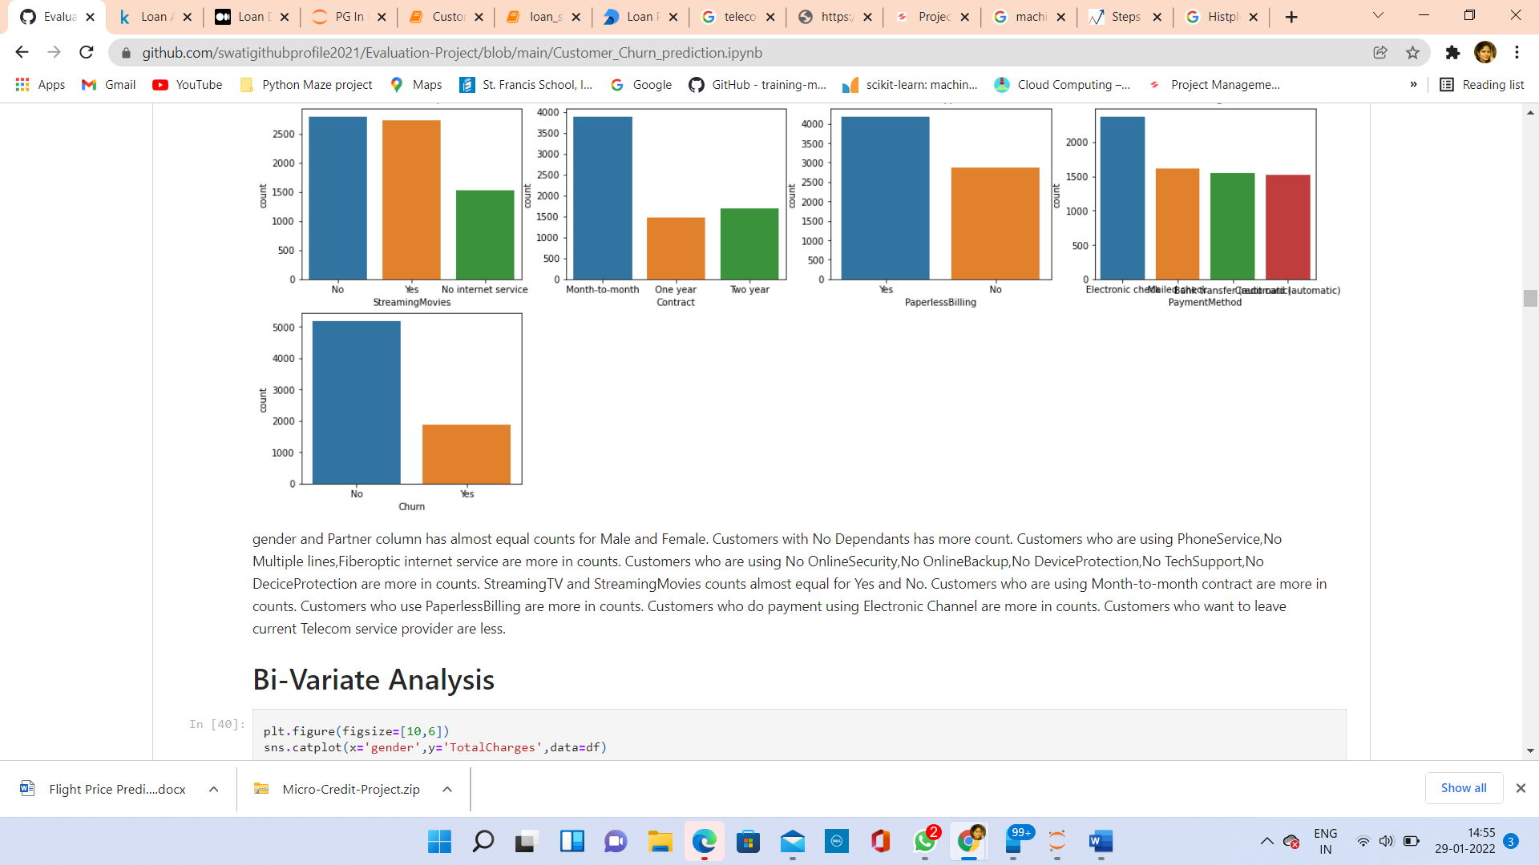

**Observations from countplot:**

* gender and Partner column has almost equal counts for Male and Female.
* Customers with No Dependants has more count.
* Customers who are using PhoneService, No Multiple lines, Fiberoptic internet service are more in counts.
* Customers who are using No OnlineSecurity, No OnlineBackup, No DeviceProtection, No TechSupport, No DeciceProtection are more in counts.
* StreamingTV and StreamingMovies counts almost equal for Yes and No.
* Customers who are using Month-to-month contract are more in counts.
* Customers who use PaperlessBilling are more in counts.
* Customers who do payment using Electronic Channel are more in counts.
* Customers who want to leave current Telecom service provider are less.

**Bi-Variate Analysis:**

Bivariate analysis means the analysis of bivariate data. It is one of the simplest forms of statistical analysis, used to find out if there is a relationship between two sets of values. Bivariate analysis is the analysis of exactly two variables.

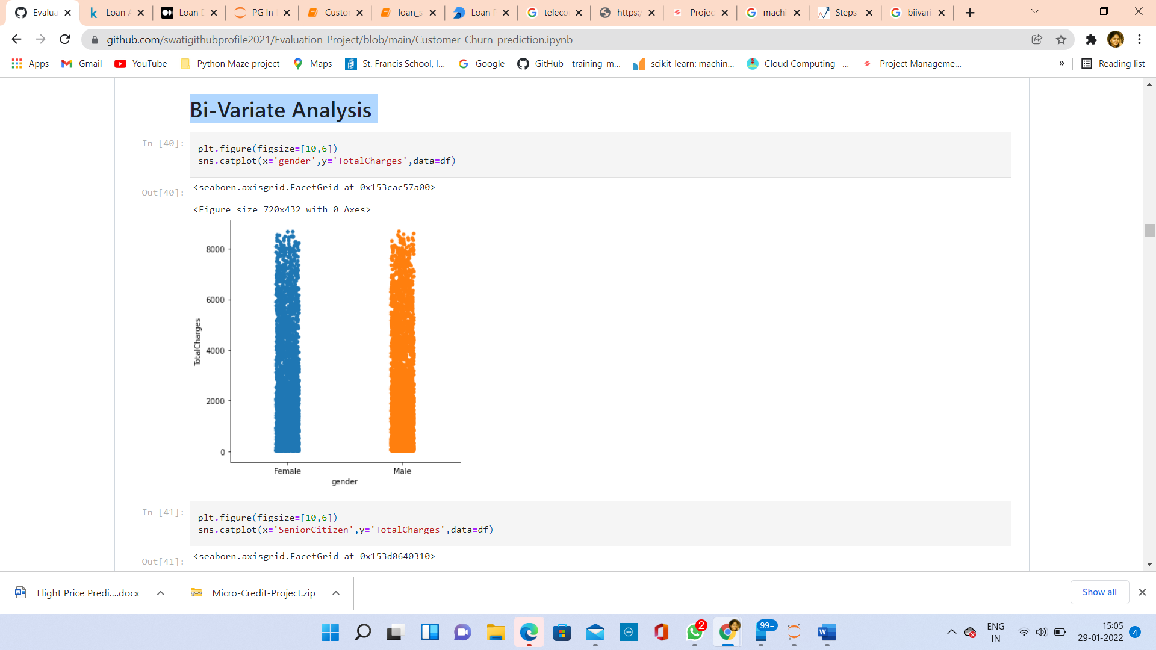

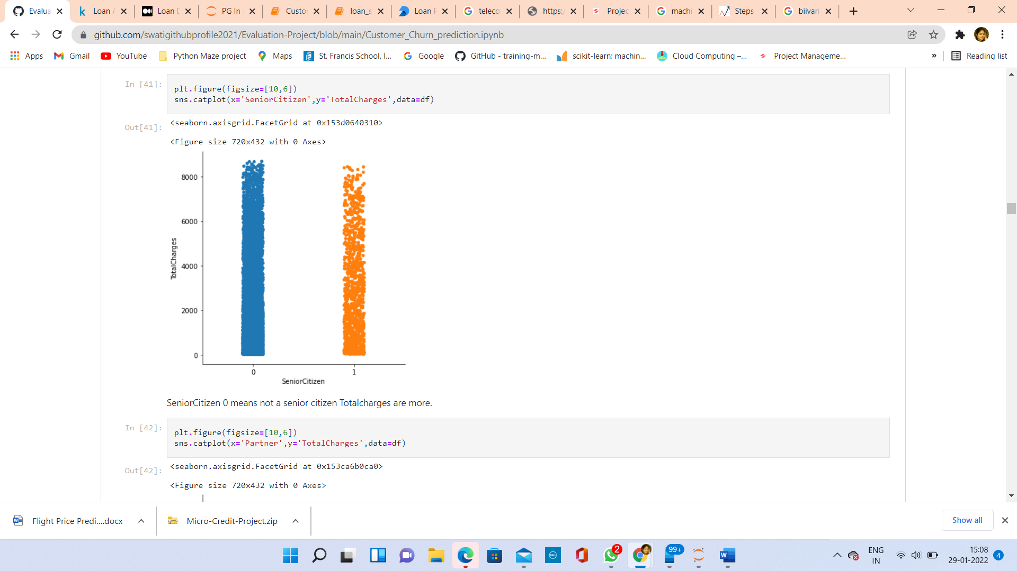

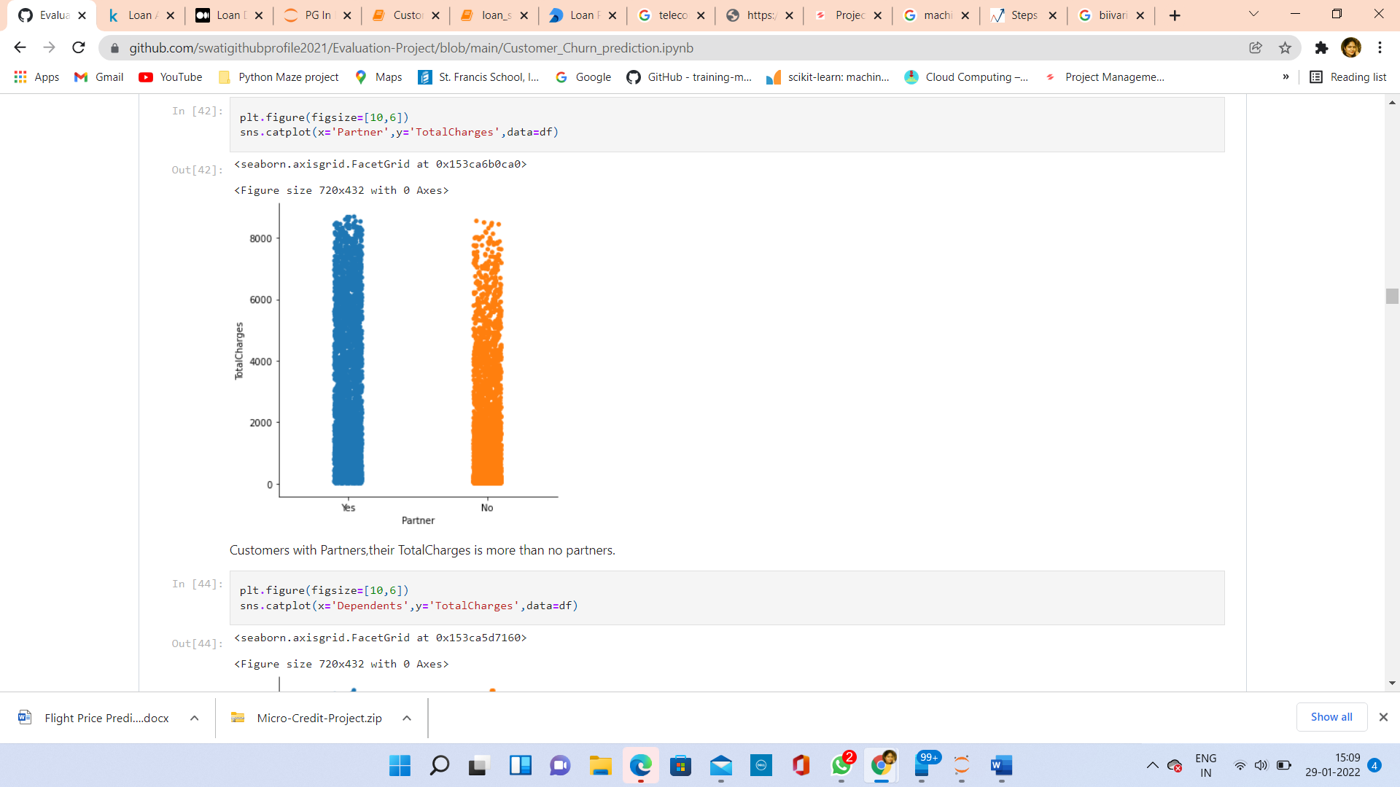

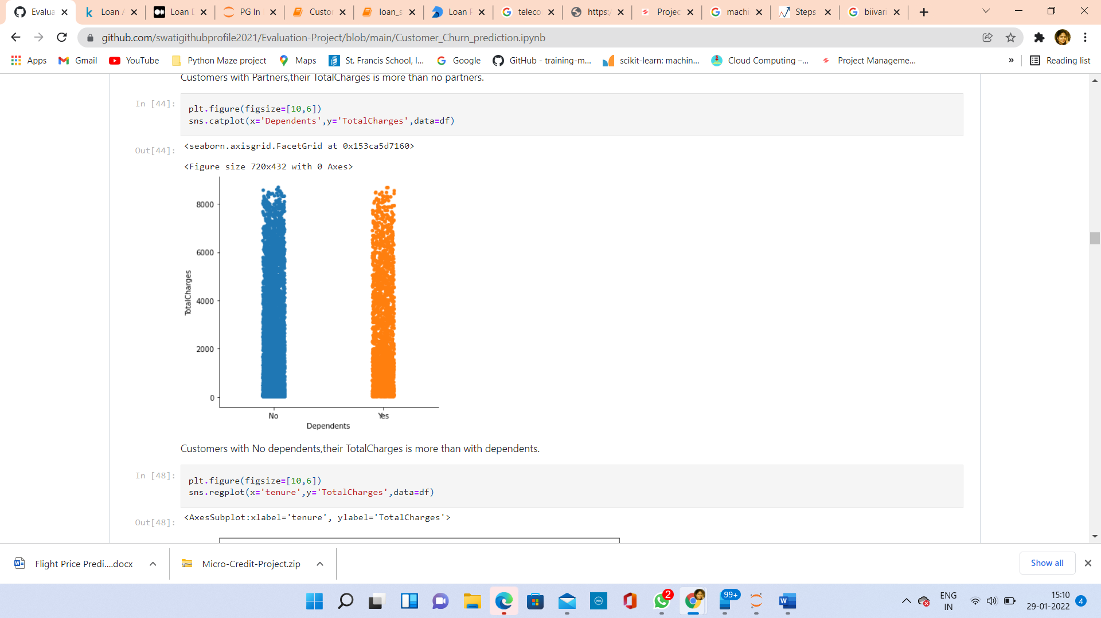

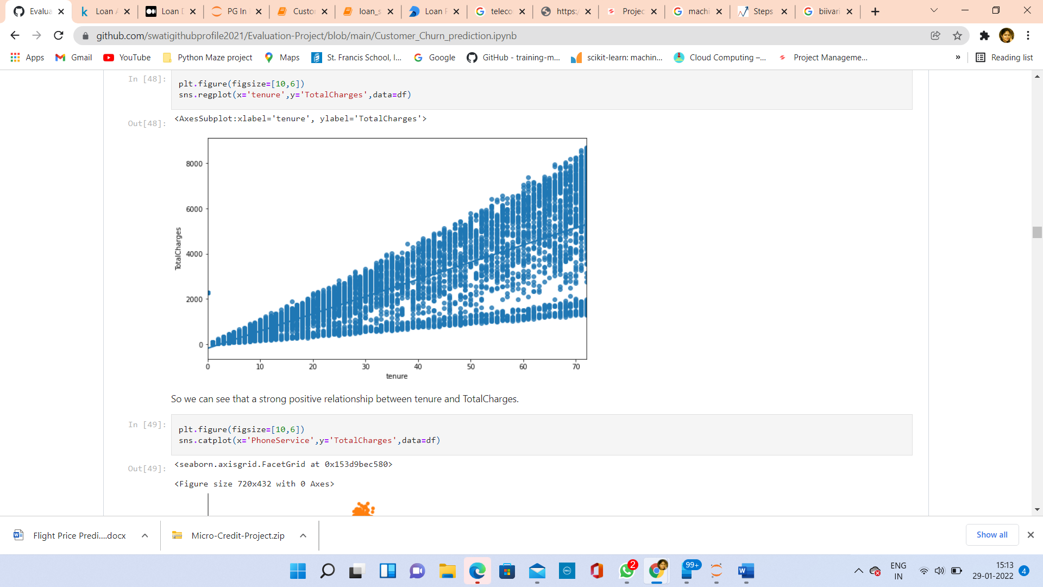

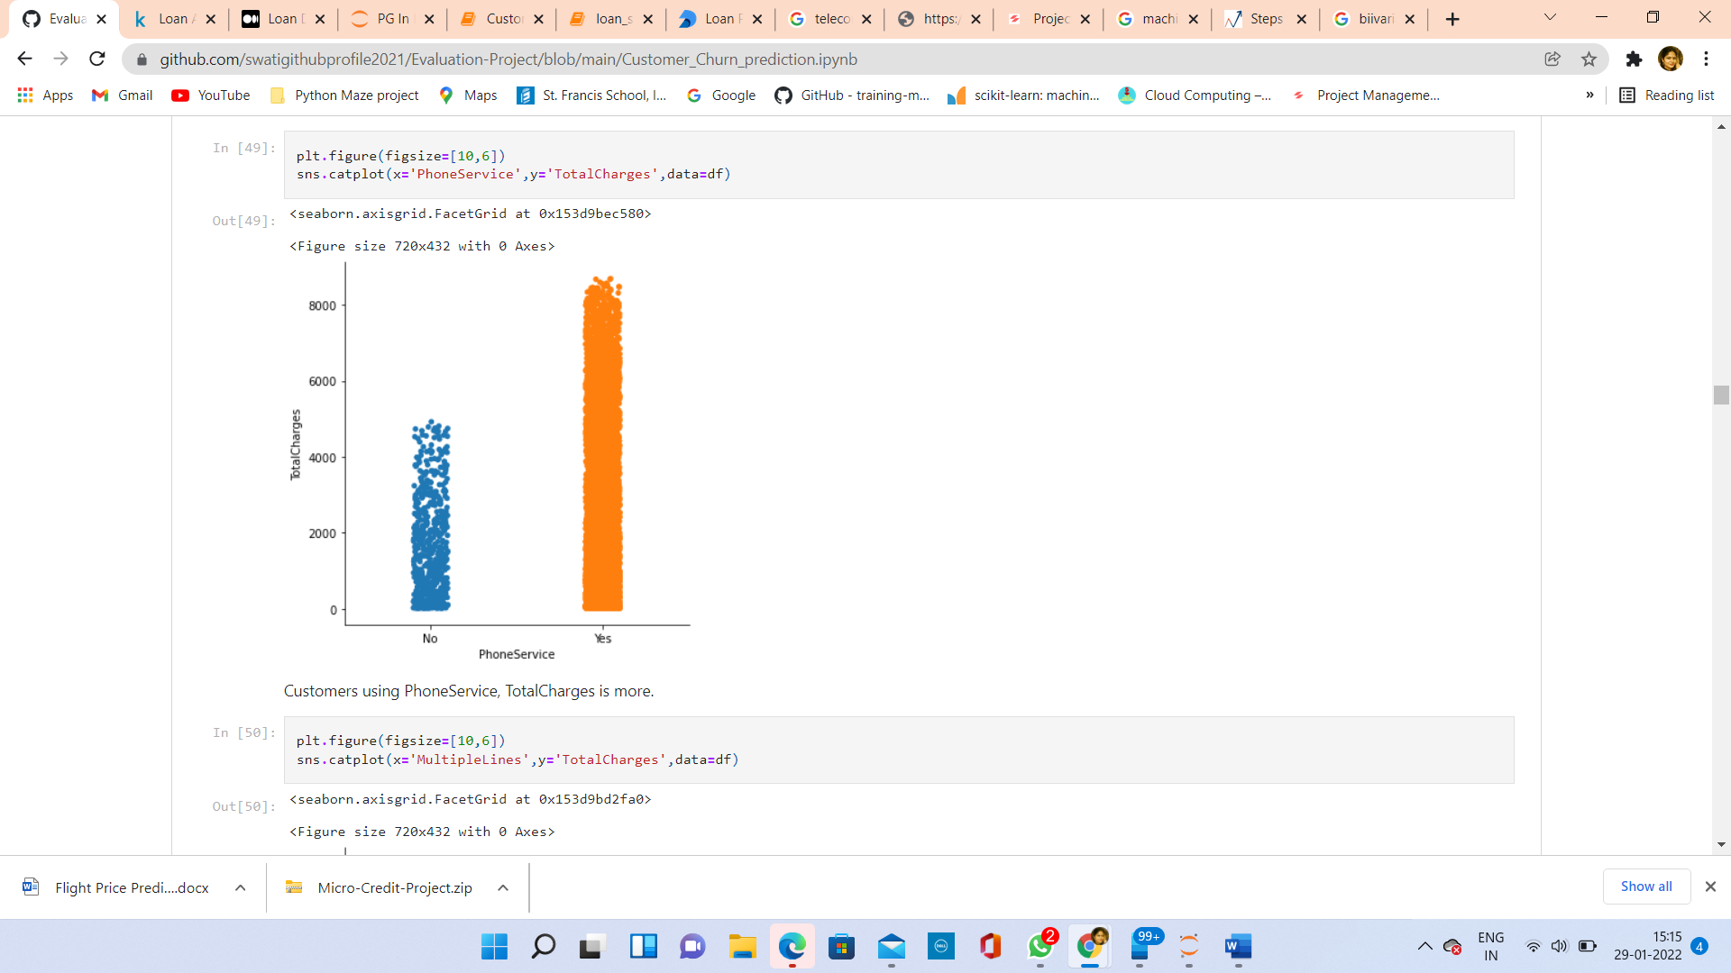

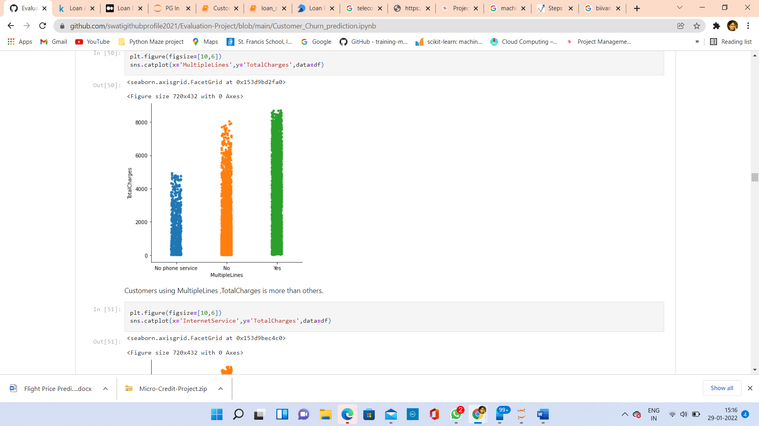

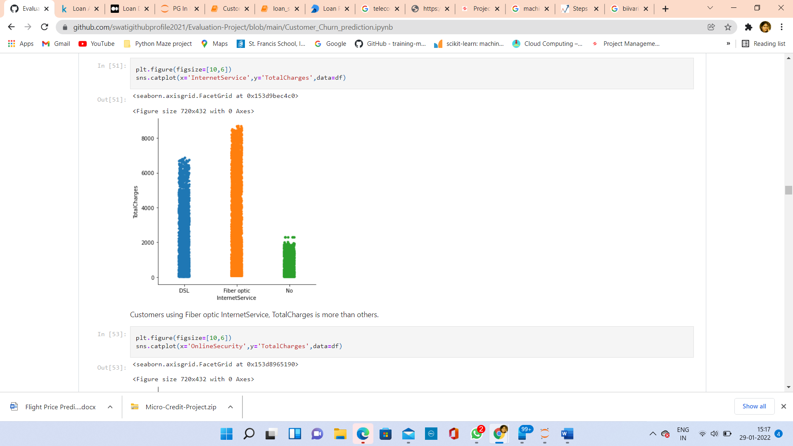

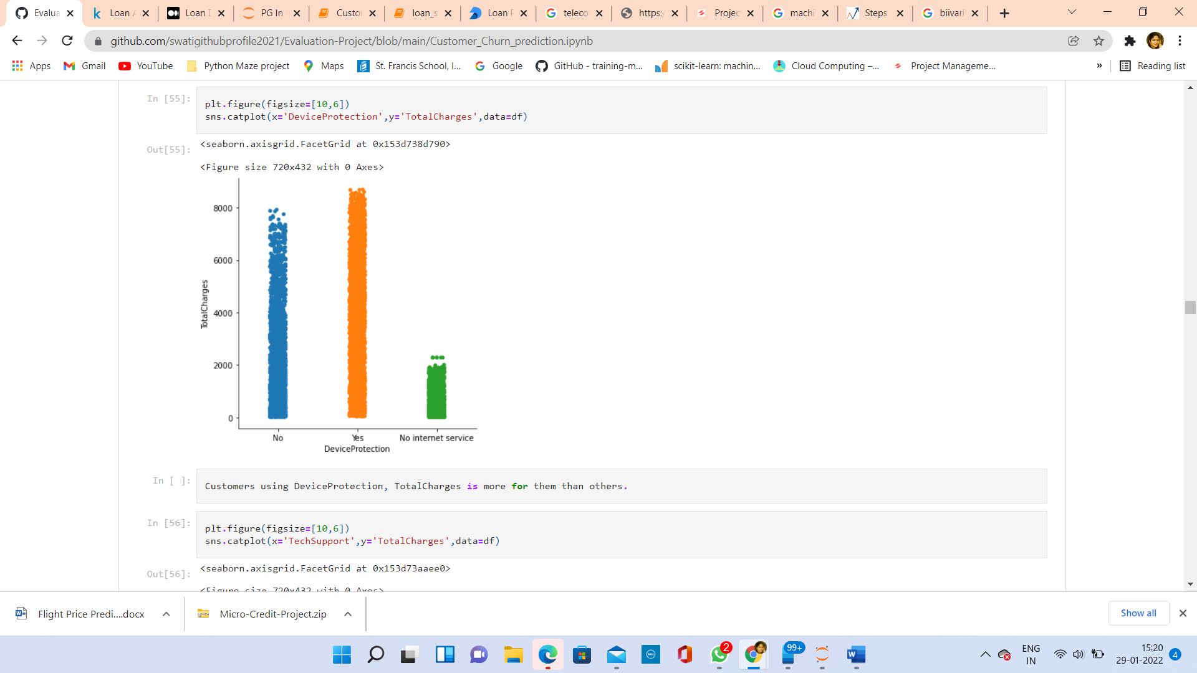

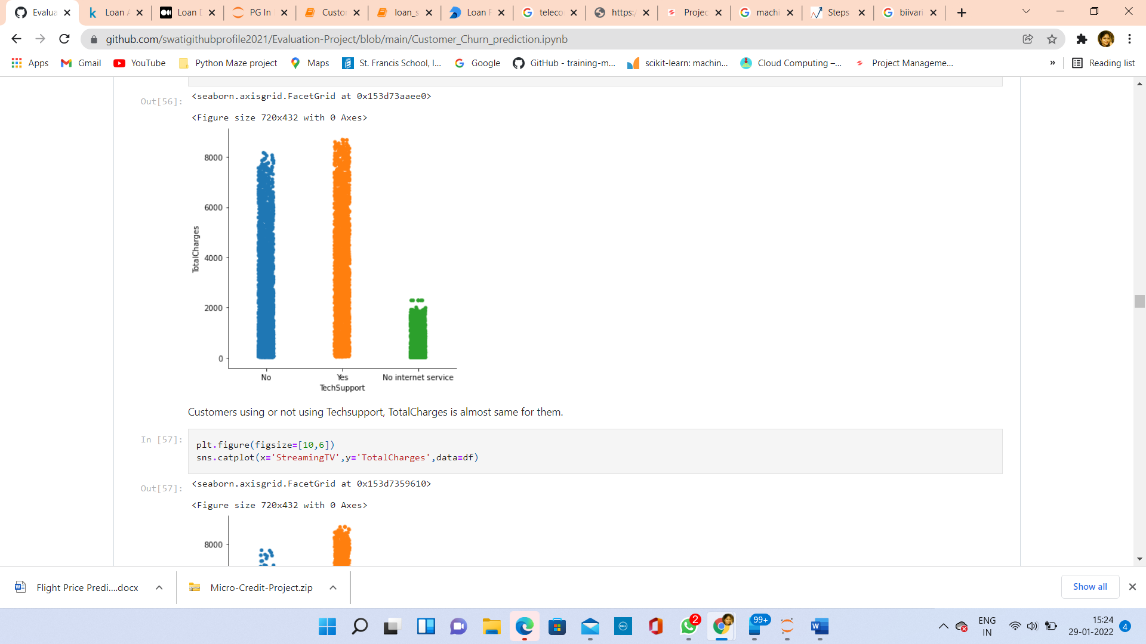

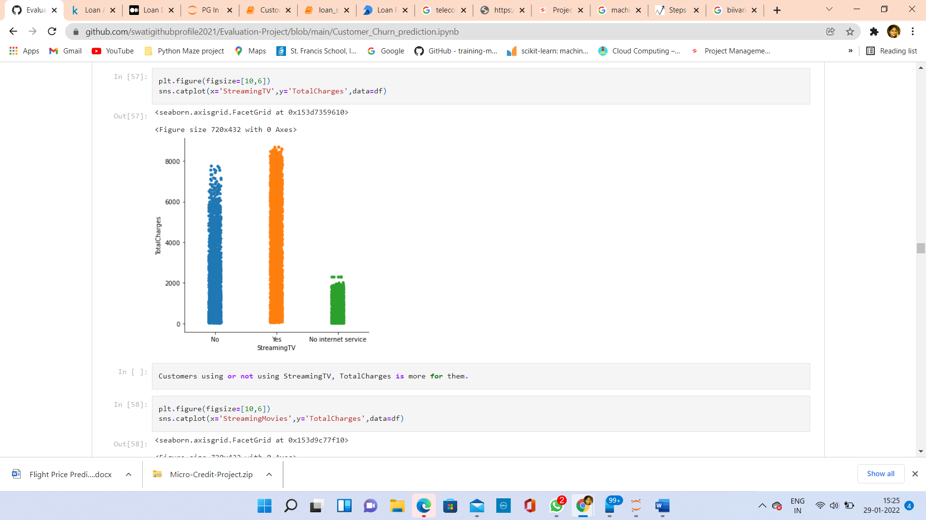

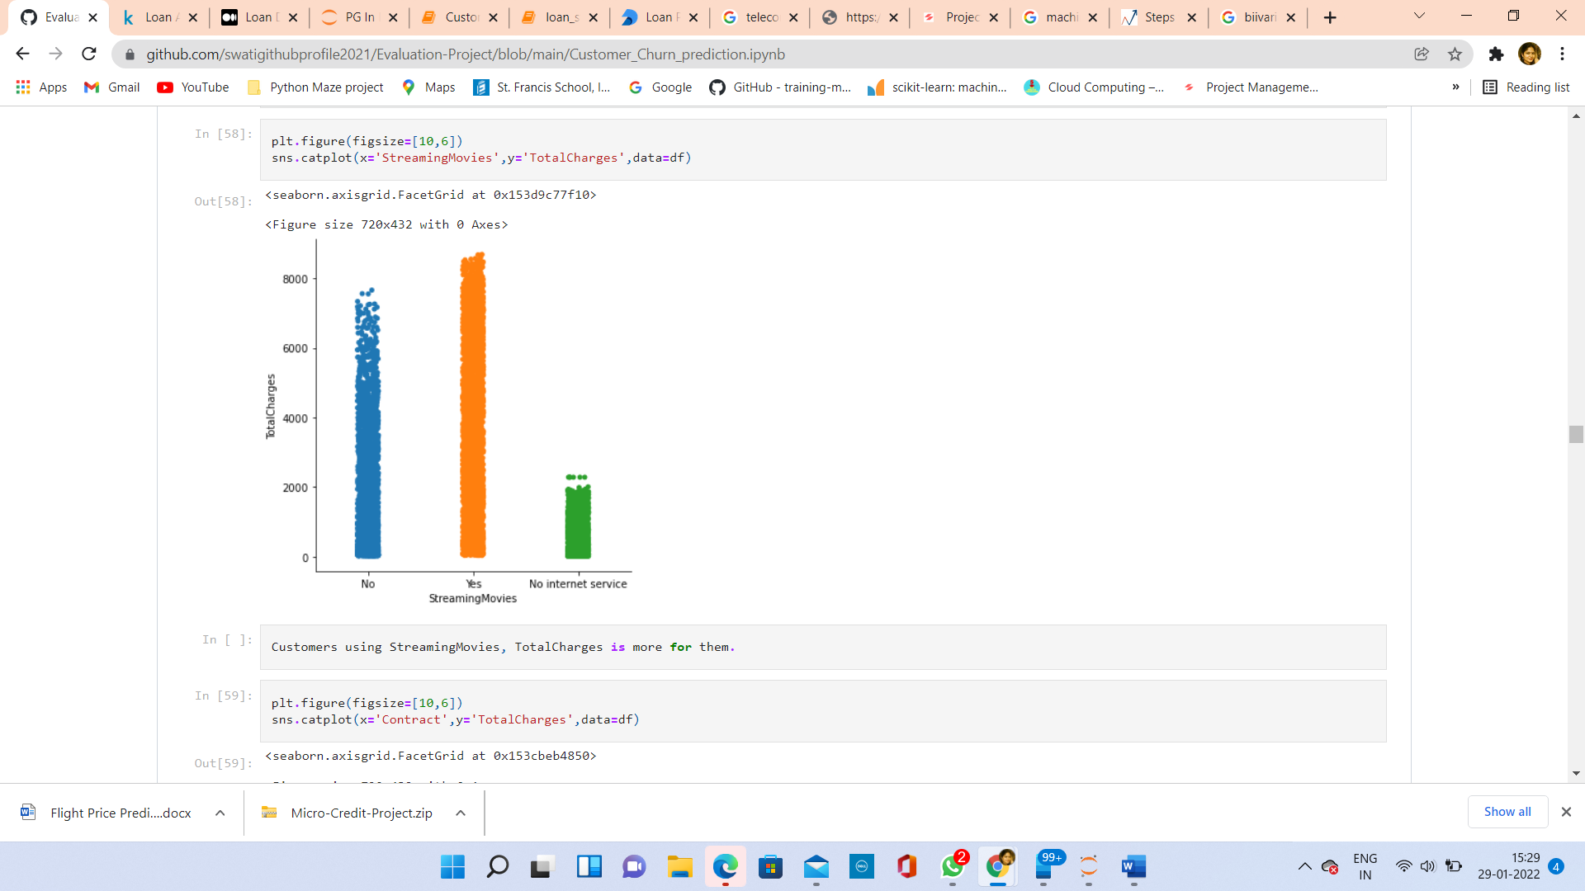

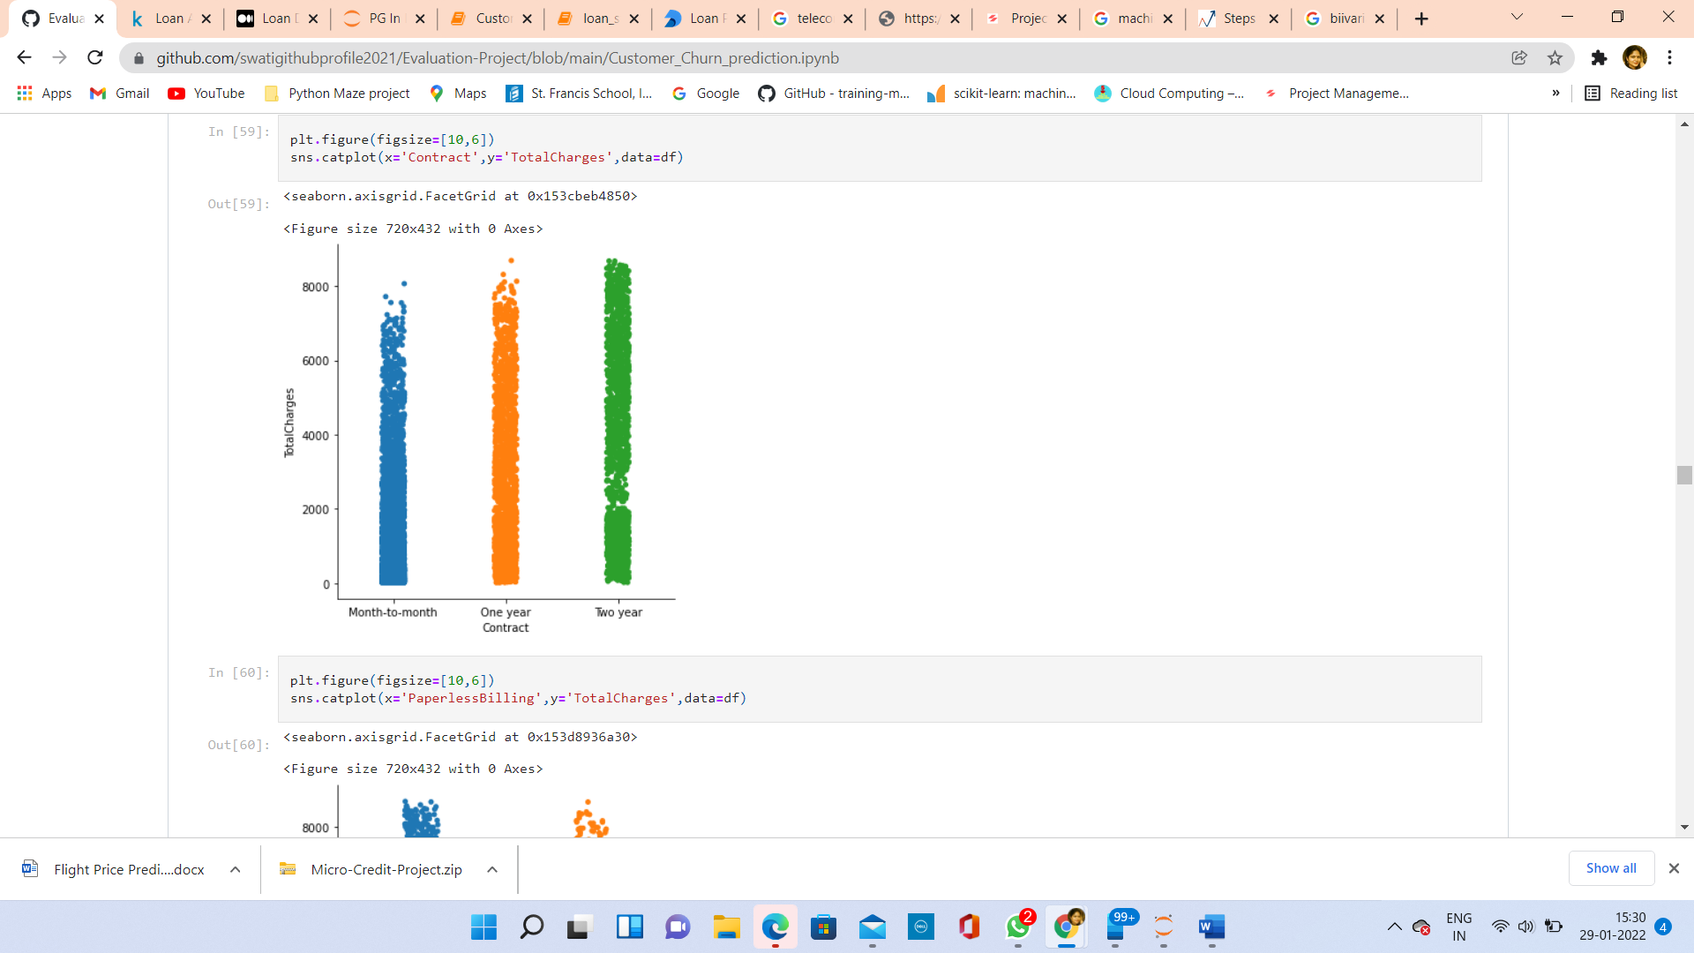

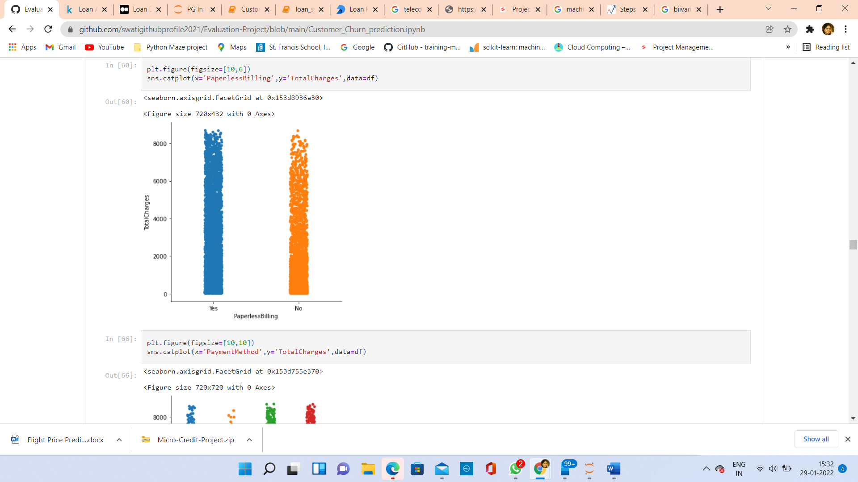

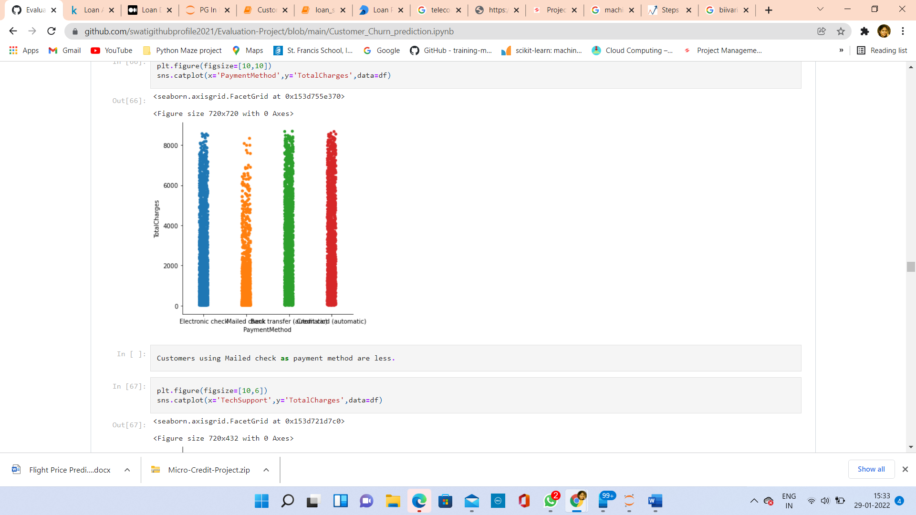

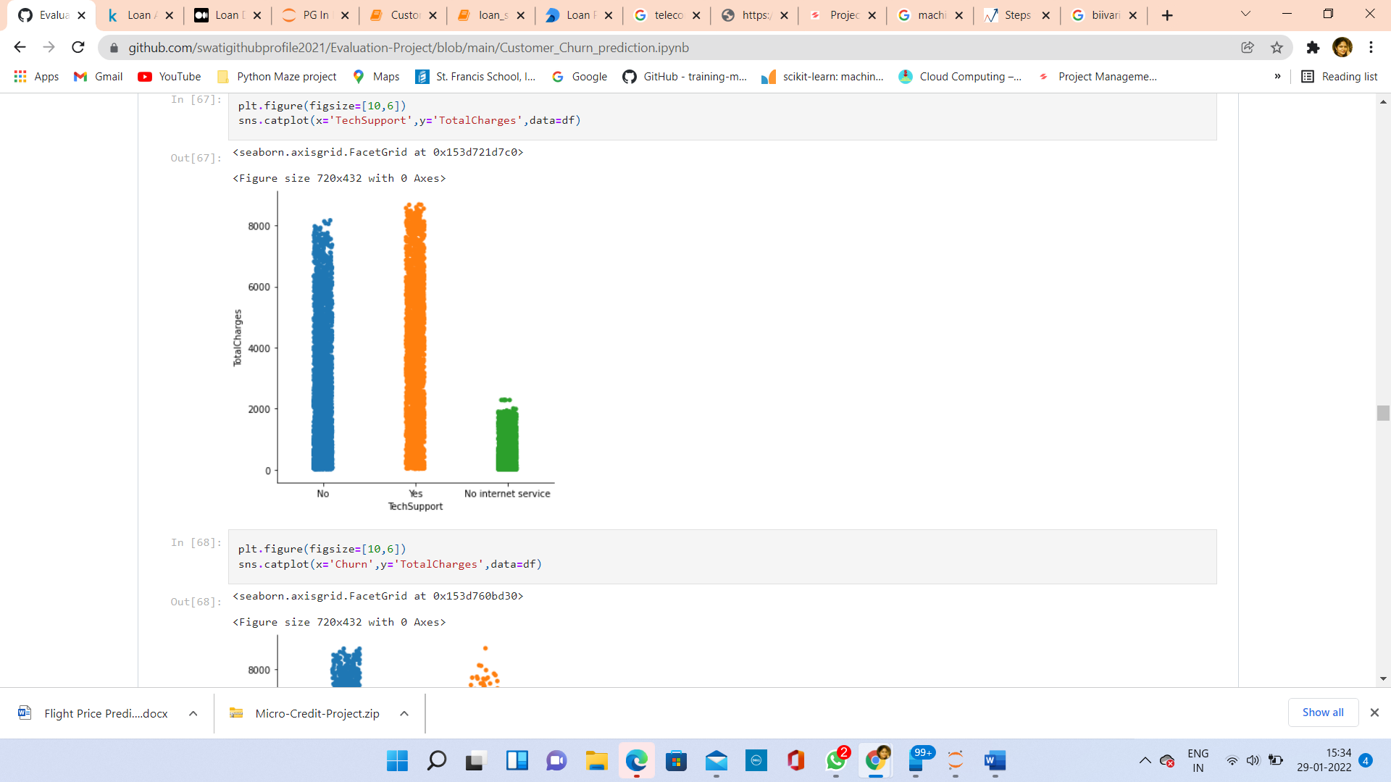

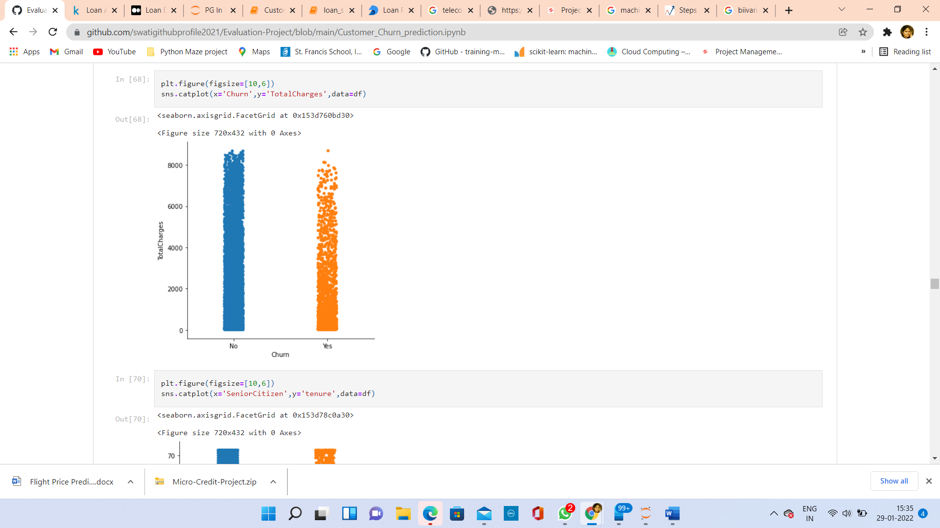

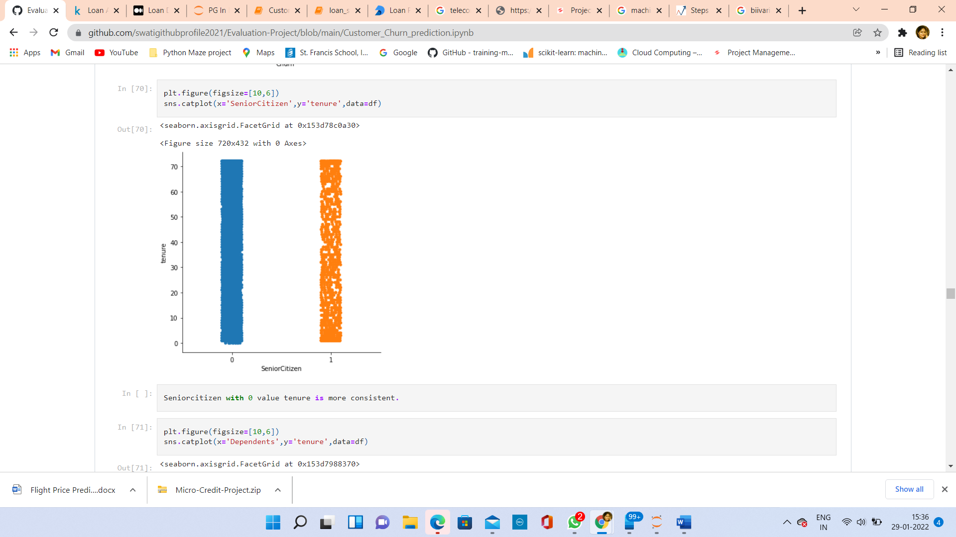

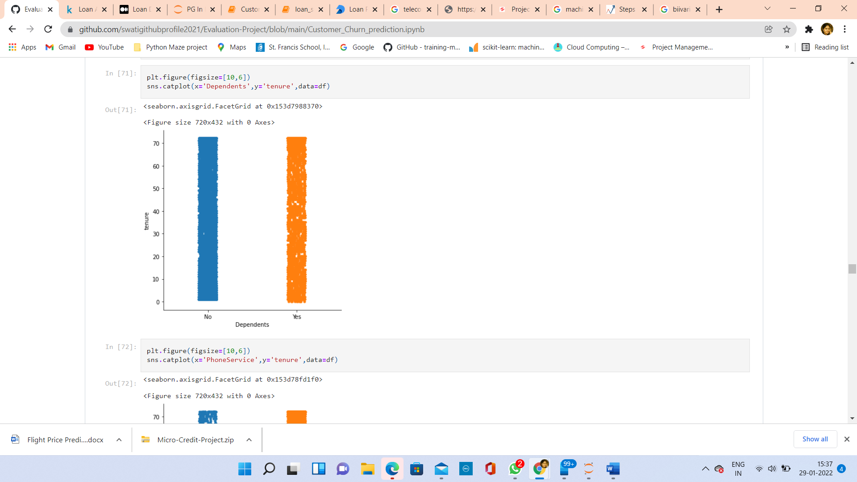

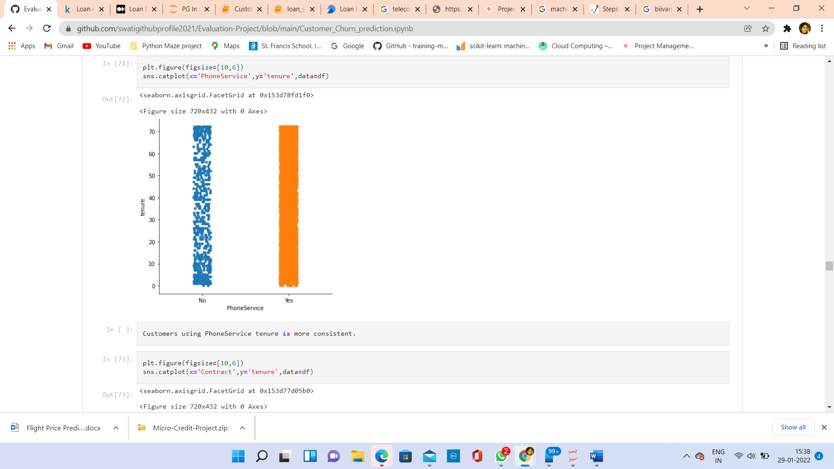

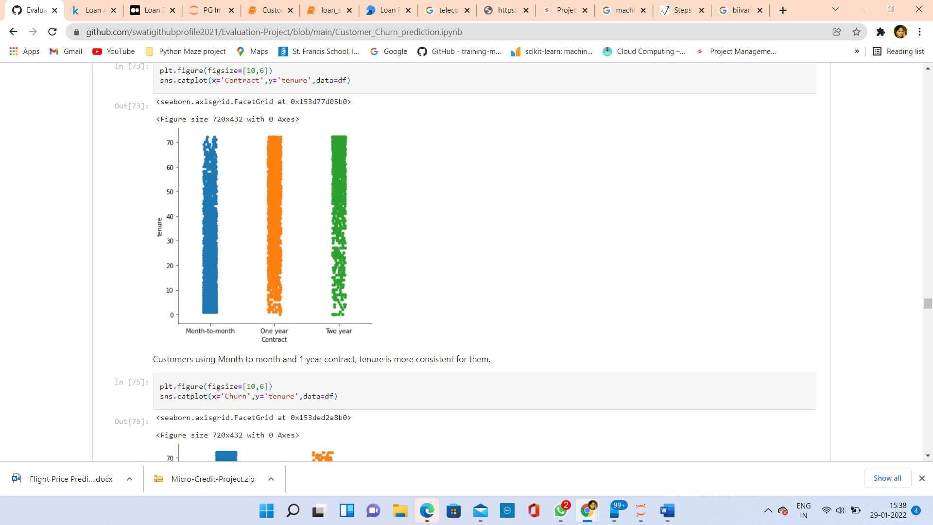

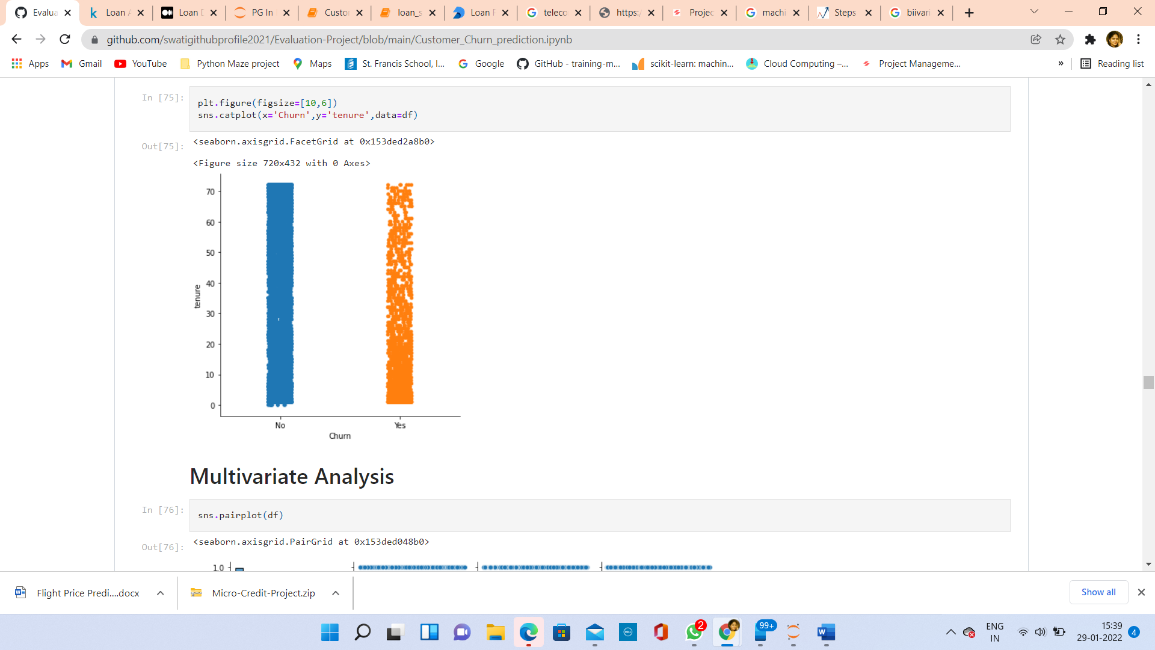

**Observations from Bi-Variate Analysis:**

* SeniorCitizen 0 means not a senior citizen, Totalcharges are more for those who are not senior citizen.
* Customers with Partners, their TotalCharges is more than no partners.
* Customers with No dependents, their TotalCharges is more than with dependents.
* A strong positive relationship between tenure and TotalCharges.
* Customers using PhoneService, TotalCharges is more.
* Customers using MultipleLines, TotalCharges is more than others.
* Customers using Fiber optic InternetService, TotalCharges is more than others.
* Customers using OnlineSecurity, TotalCharges is more than others.
* Customers using OnlineBackup, TotalCharges is more for them than others.
* Customers using DeviceProtection, TotalCharges is more for them than others.
* Customers using or not using Techsupport, TotalCharges is almost same for them.
* Customers using or not using StreamingTV, TotalCharges is more for them.
* Customers using StreamingMovies, TotalCharges is more for them.
* Customers using PaperlessBilling, their Totalcharges is more.
* Customers using Mailed check as payment method are less.
* Seniorcitizen with 0 value tenure is more consistent.
* Customers using PhoneService tenure is more consistent.
* Customers using Month to month and 1 year contract, tenure is more consistent for them
* Customers who will continue the telecom service, their tenure is more consistent.

**Data Pre-processing**

The process of transforming the raw data for using them in the algorithms.

**Since most of the columns have values 2,3 or 4, so have used OrdinalEncoder

Ordinal Encoding: This step is done to convert all the categorical data into numerical data.

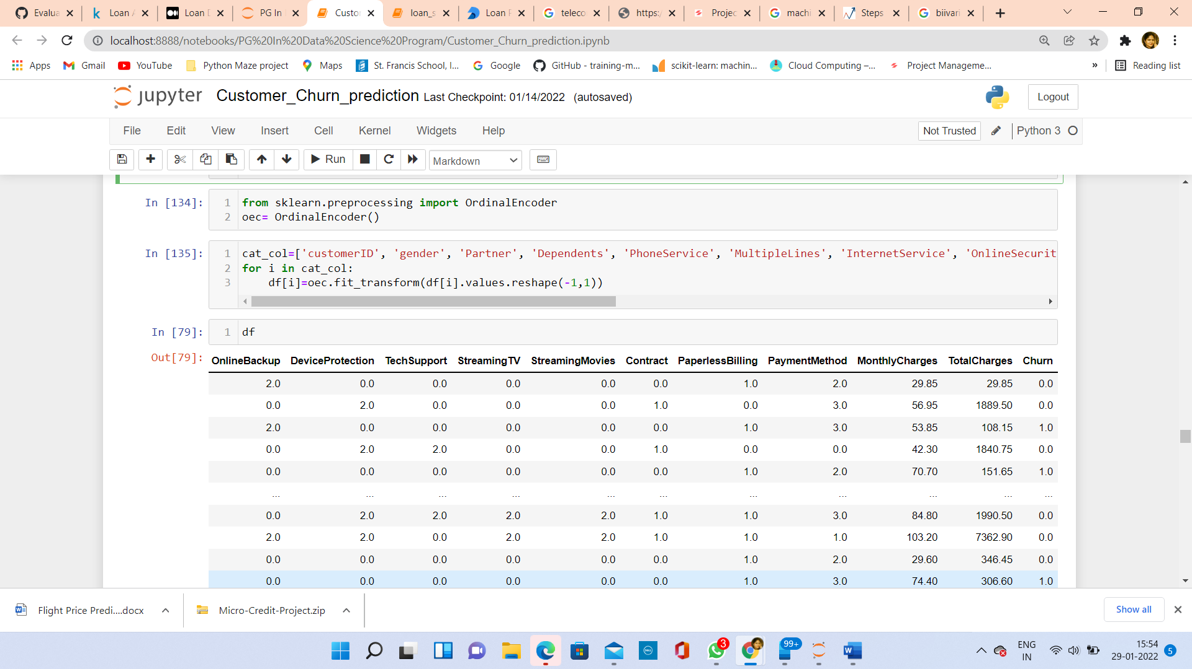

**Correlation:**

We can check correlation using following code:

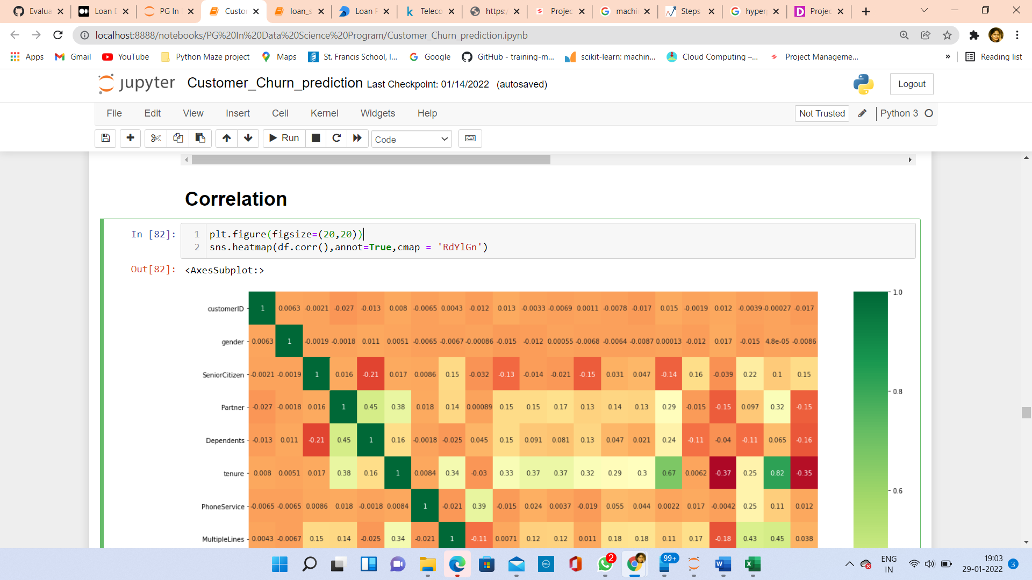

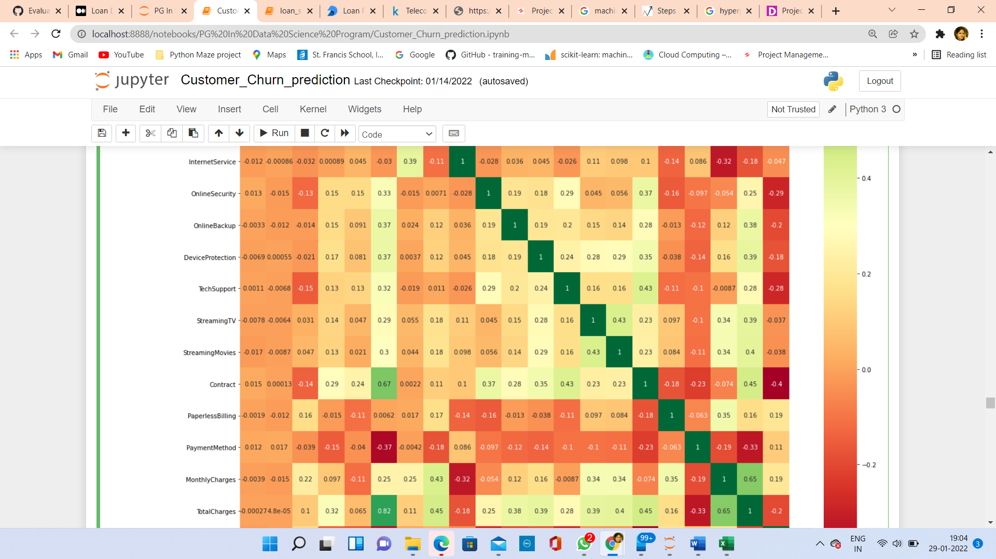

**Observations from Correlation Matrix:**

CustomerID and gender has very weak relationship with Target column.

tenure has very strong positive relation with TotalCharges.

InrenetService, PaymentMethod and Churn have negative correlation with Target column.

tenure, MonthlyCharges have good positive correlation with target more than 60%.

**Skewness:**

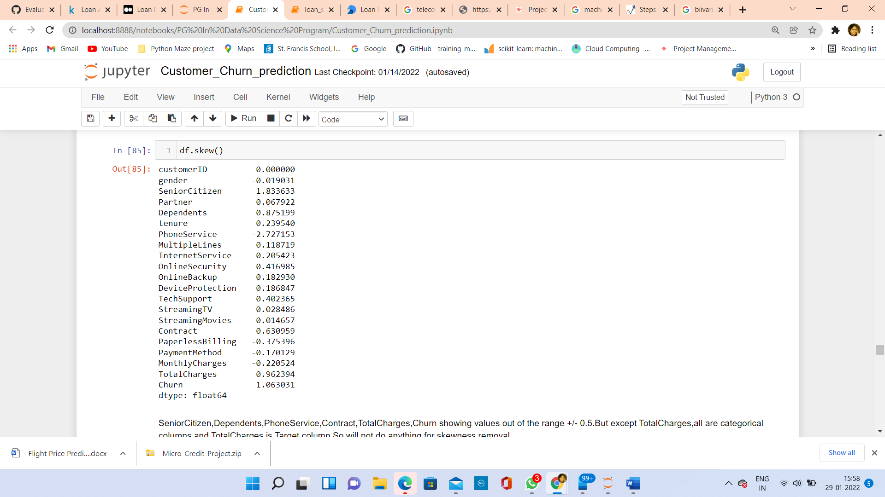

SeniorCitizen, Dependents, PhoneService, Contract, TotalCharges, Churn showing values out of the range +/- 0.5. But except TotalCharges, all are categorical columns and TotalCharges is Target column, So have not done anything for skewness removal.

**Outliers:**

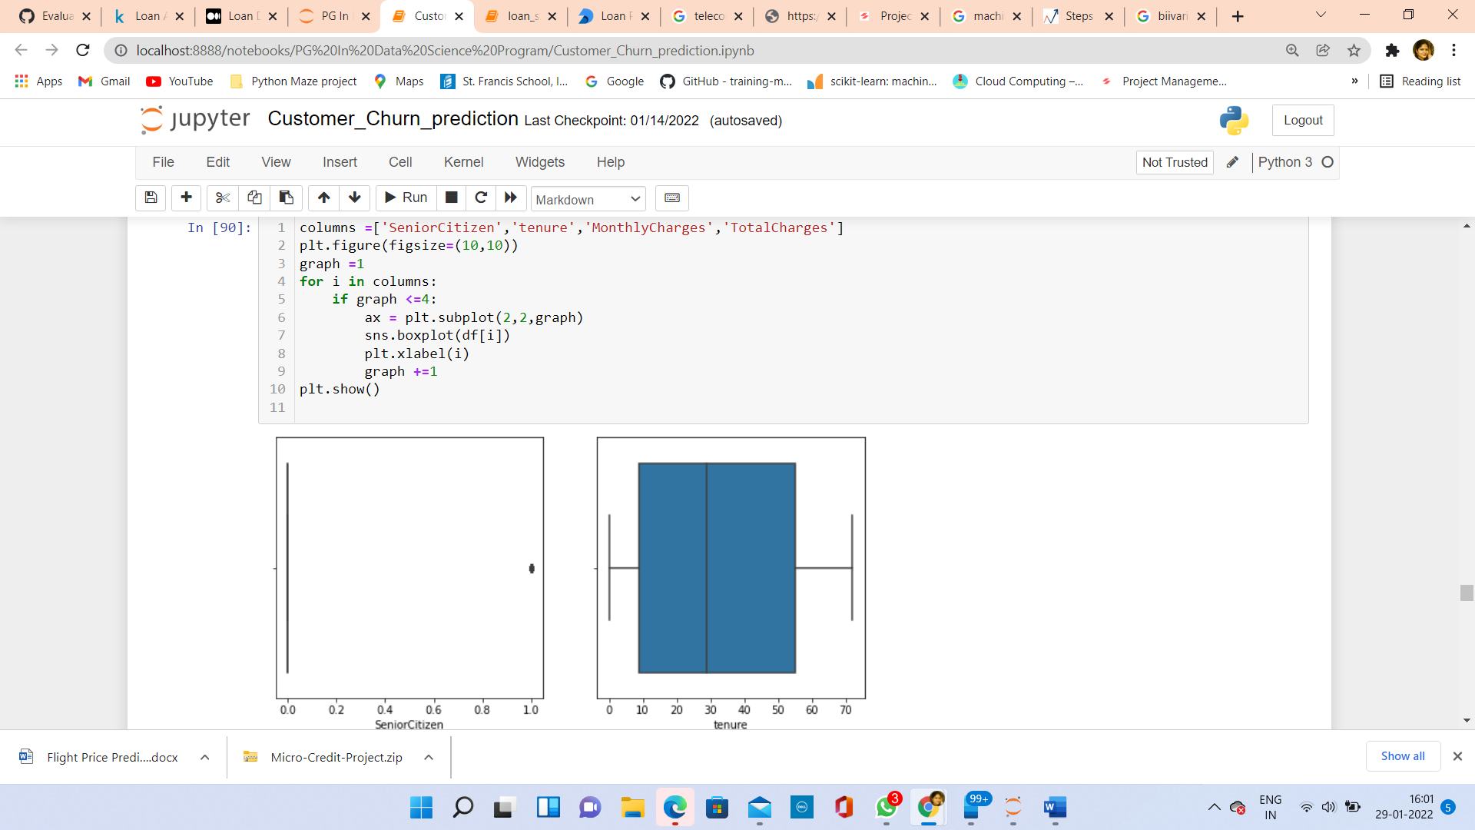

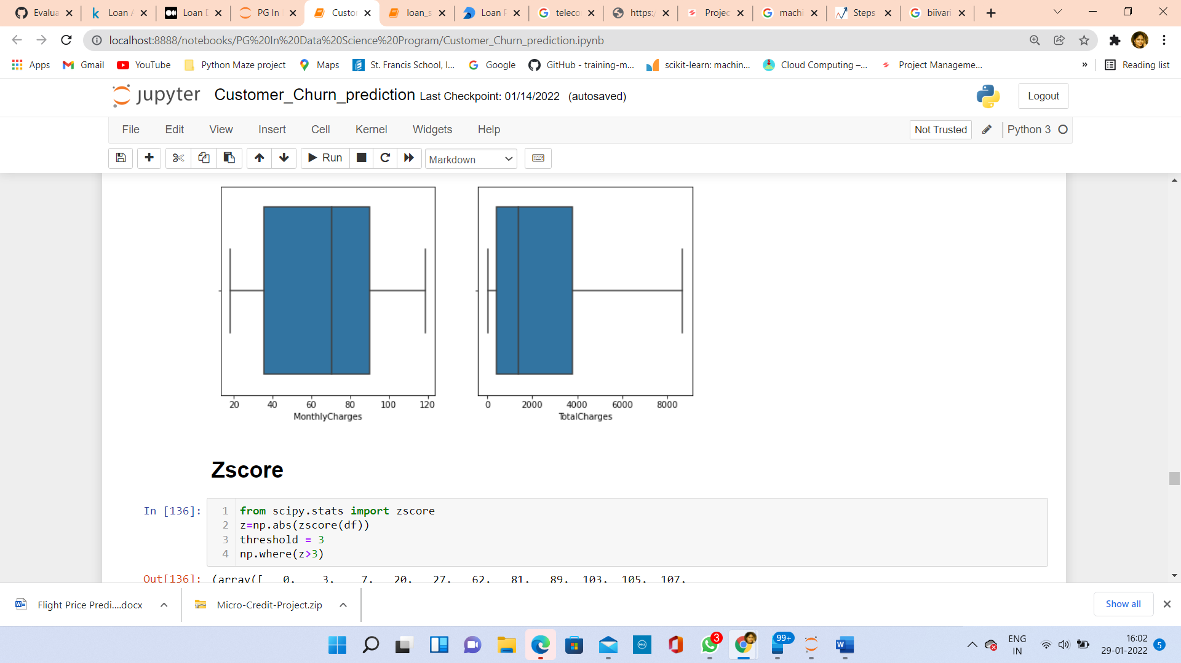

Only SeniorCitizen column showing outliers present.

**ZScore :**

Z score is also called standard score. This score helps to understand if a data value is greater or smaller than mean and how far away it is from the mean. More specifically, Z score tells how many standard deviations away a data point is from the mean. **Z score = (x - mean) / std**

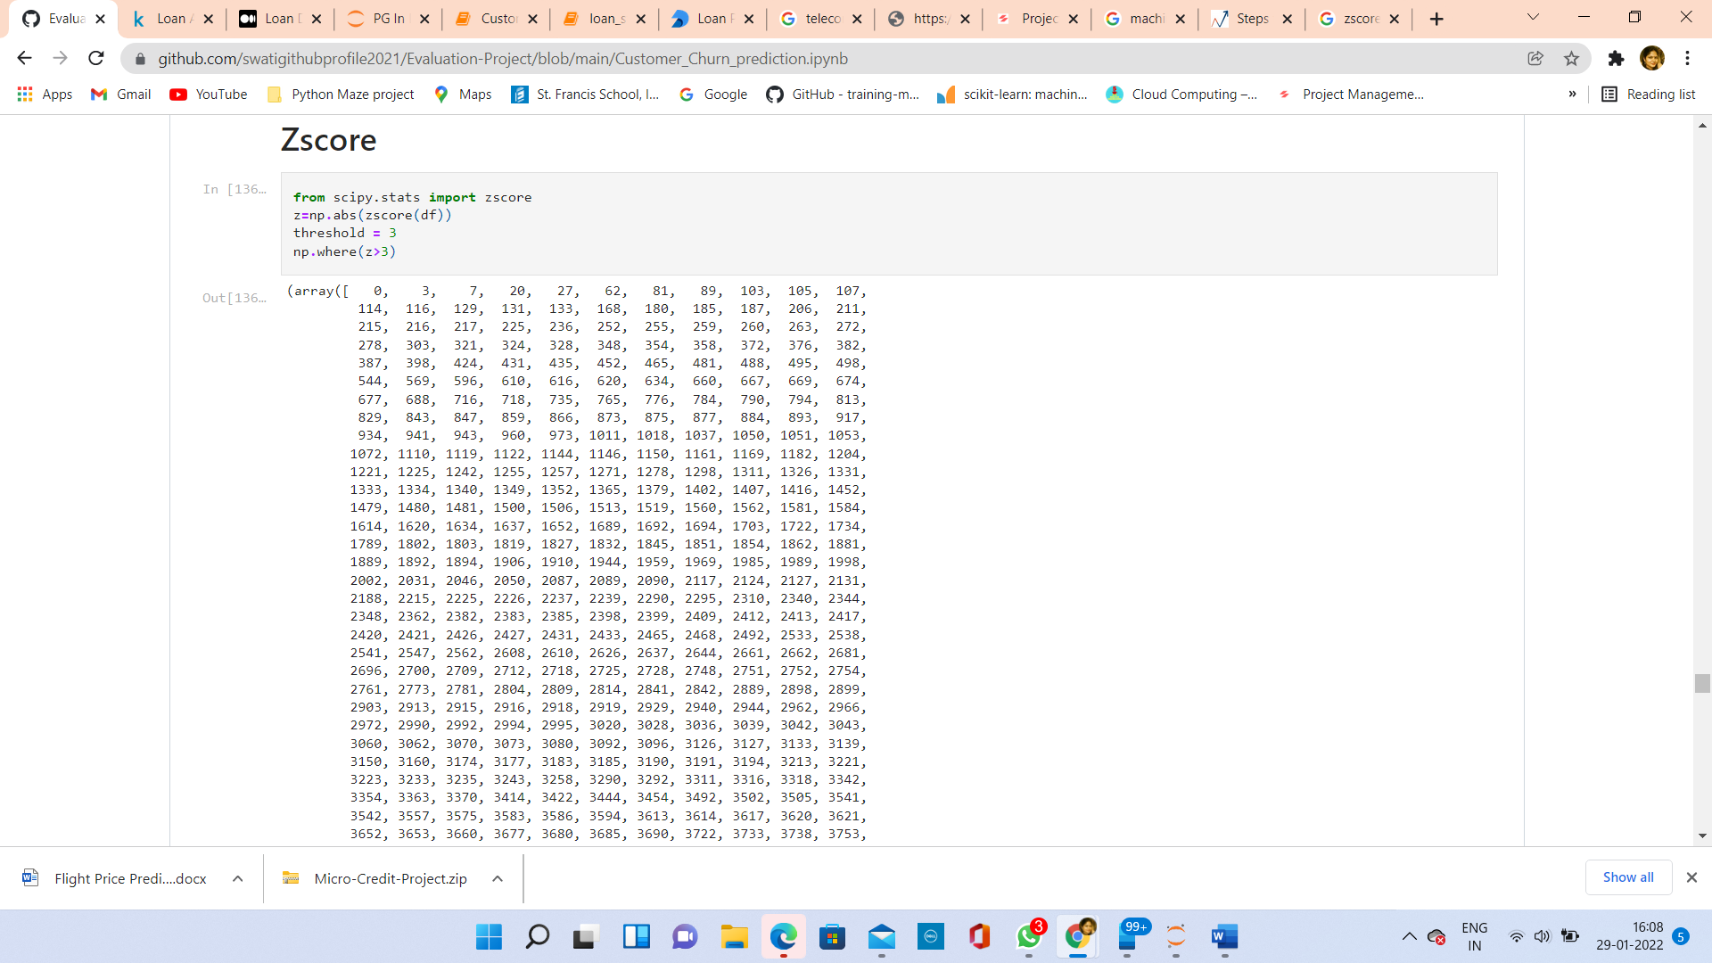

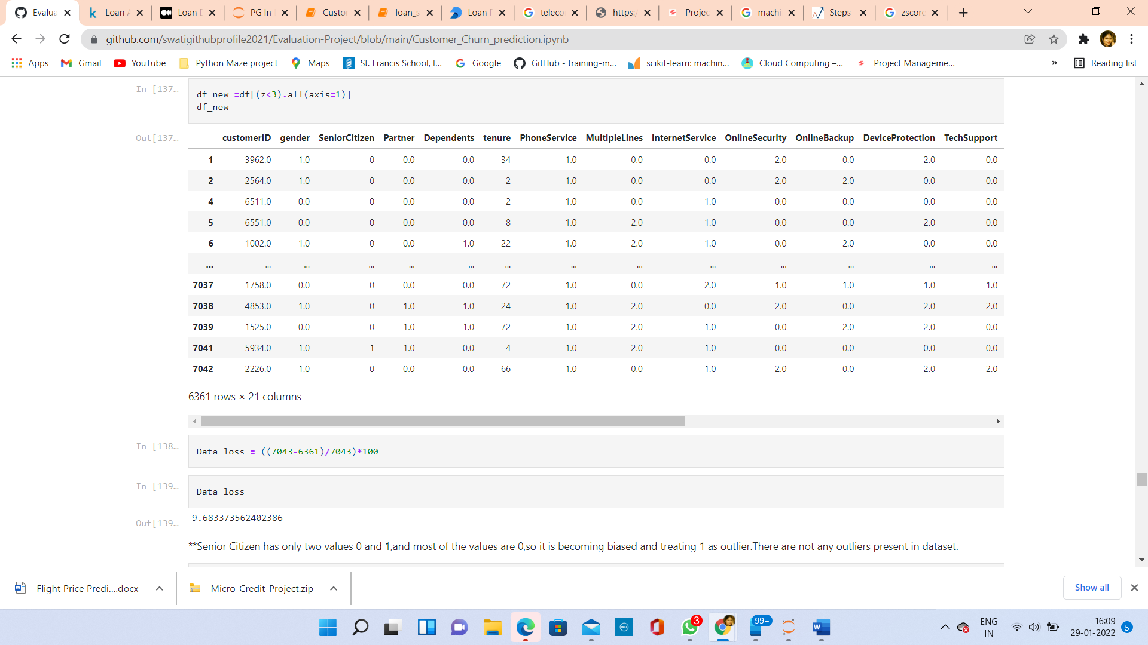

**Senior Citizen has only two values 0 and 1, and most of the values are 0, so it is becoming biased and treating 1 as outlier. There are not any outliers present in dataset.

**Separating Features and Target:**

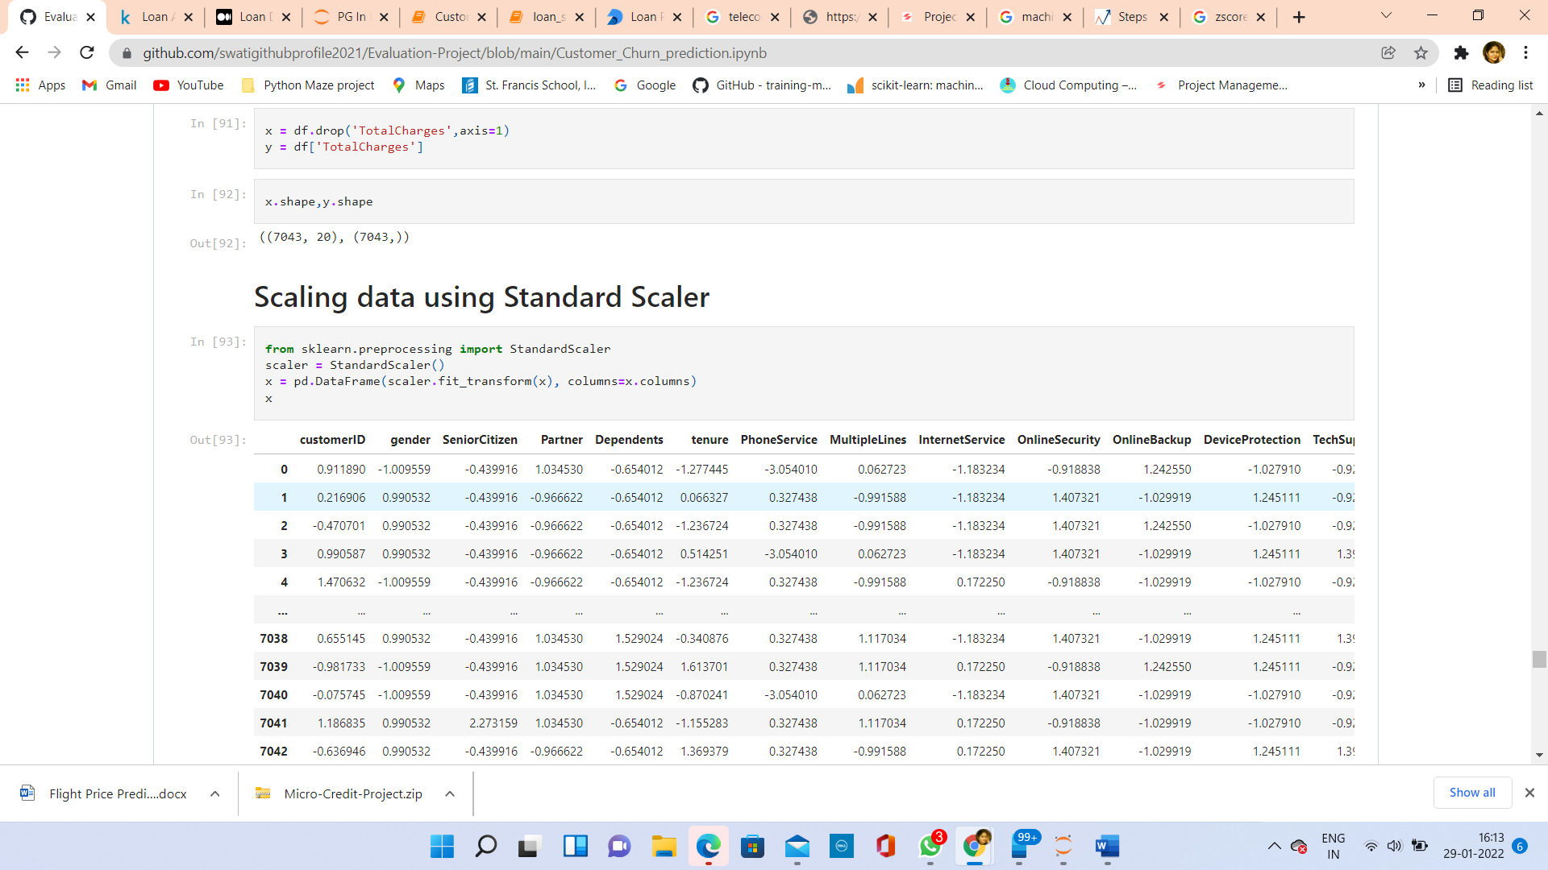

**Standardization using StandardScaler:**

Standard Scaler: It is the process of scaling the data such that the mean is 0 and standard deviation is 1.

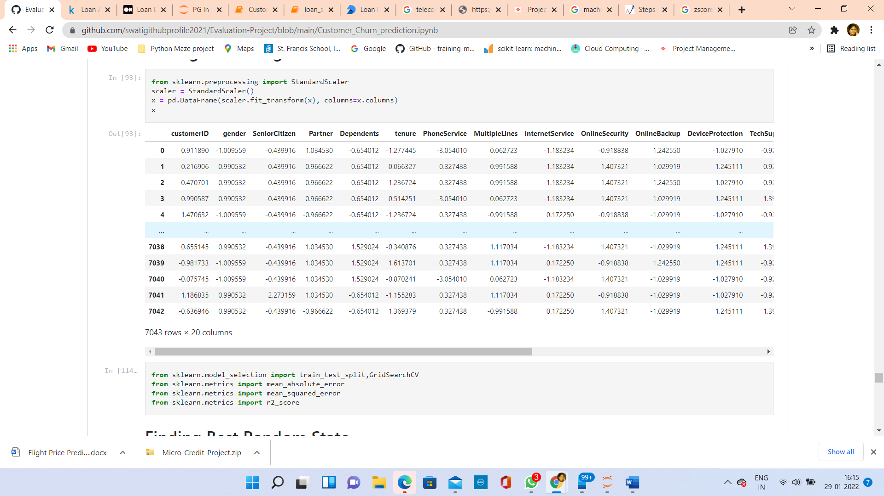

**Building Models:**

This is the main step of machine learning, fitting the model and predicting the results. Here, we use multiple different models and then select the best model. I found the model Random Forest Regressor, which gave me an R2 score of 99.8%.

Fisrt tried to find best random state at which Model gave best performance.

I have taken test data size 30% and tried to find out best random state between 1 to 200.

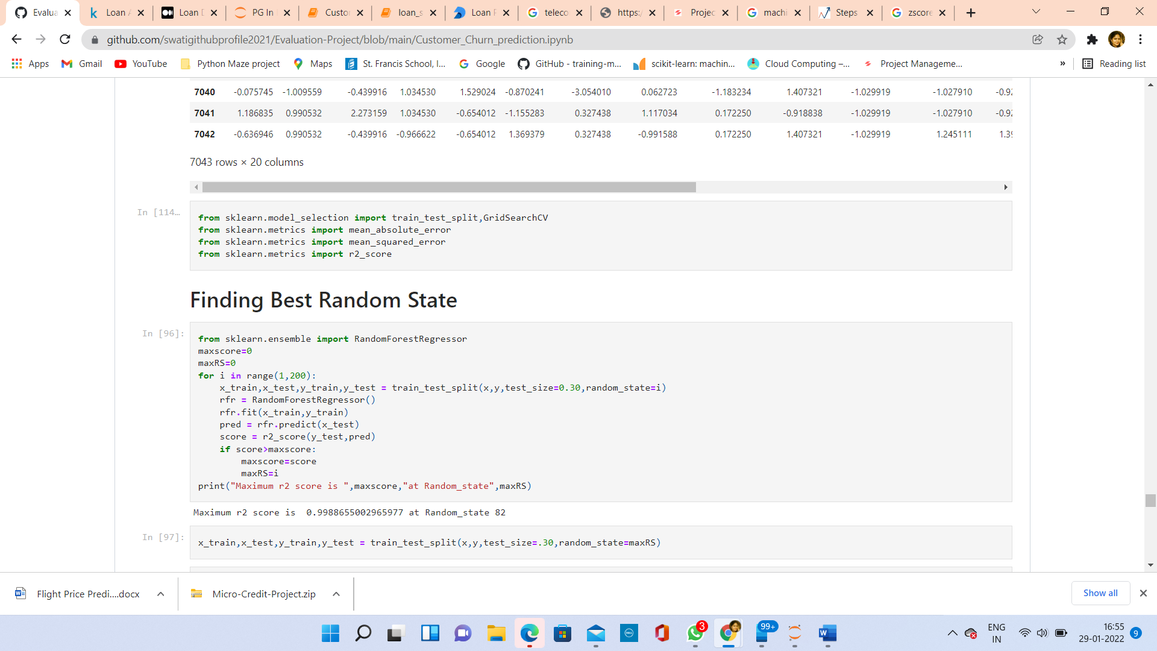

At Random state 82, Model has given 99.8 % r2 score.

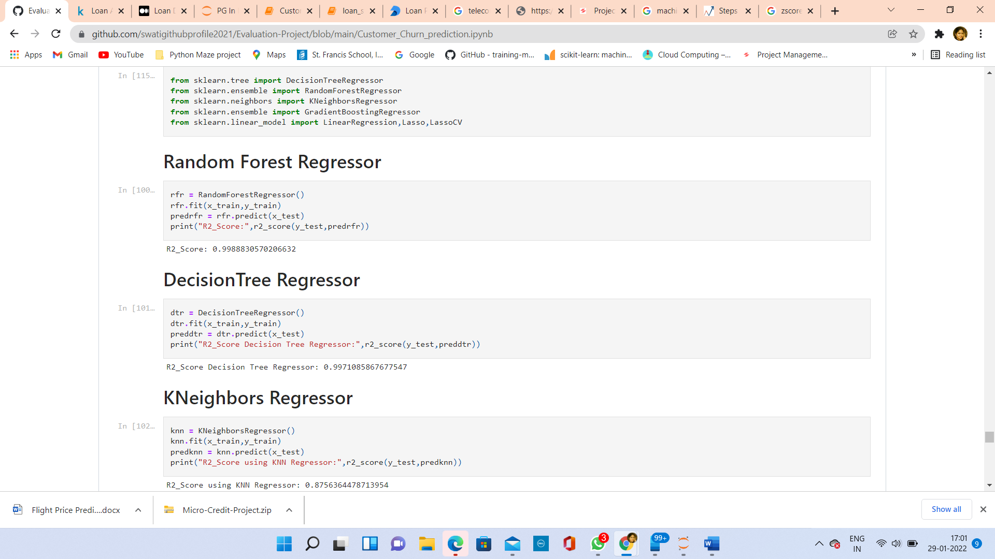

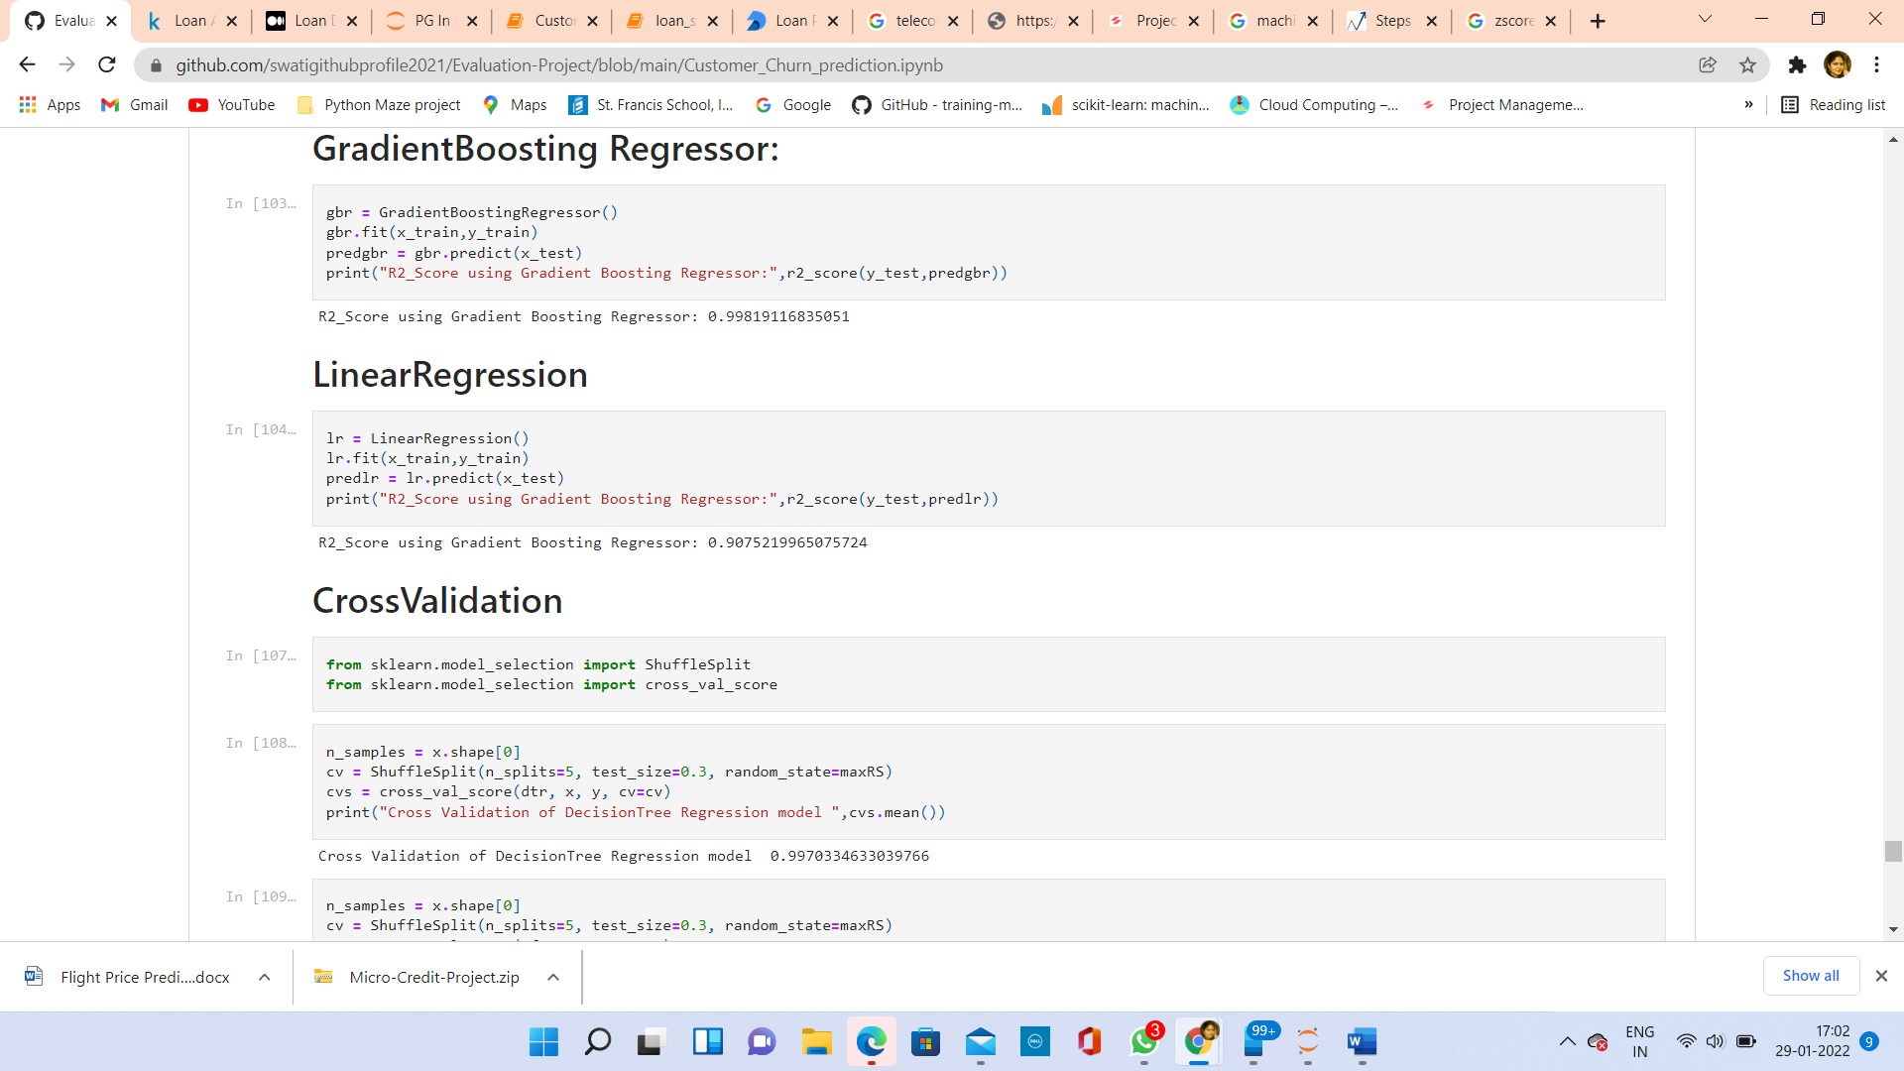

R2 Score of different Regressors:

1.Random Forest Regressor -99.8%

2.Decision Tree Regressor - 99.7%

3.KNeighbors Regressor – 87.5 %

4.Gradient Boosting Regressor - 99.8%

5.Linear Regression – 90.7 %

**Cross Validation:**

Cross-Validation is **a technique used to assess how well our Machine learning models perform on unseen data**”.

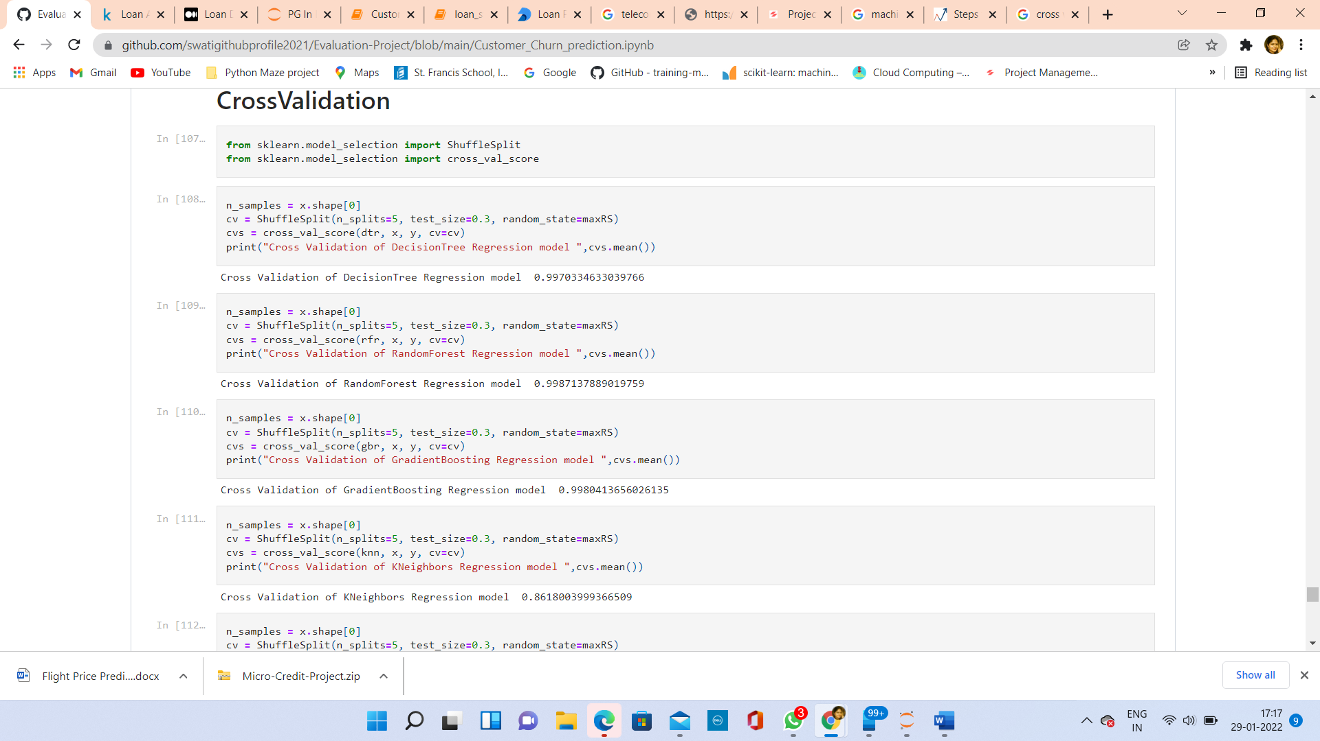

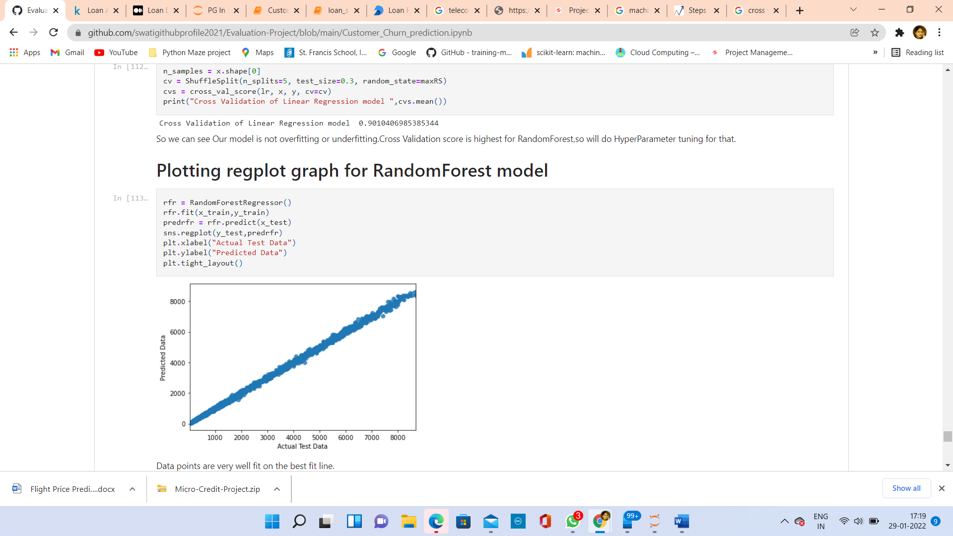

So we can see Our model is not overfitting or underfitting. Cross Validation score is almost same for models as before.

Cross Validation score is highest for RandomForest, so will do Hyperparameter tuning for that.

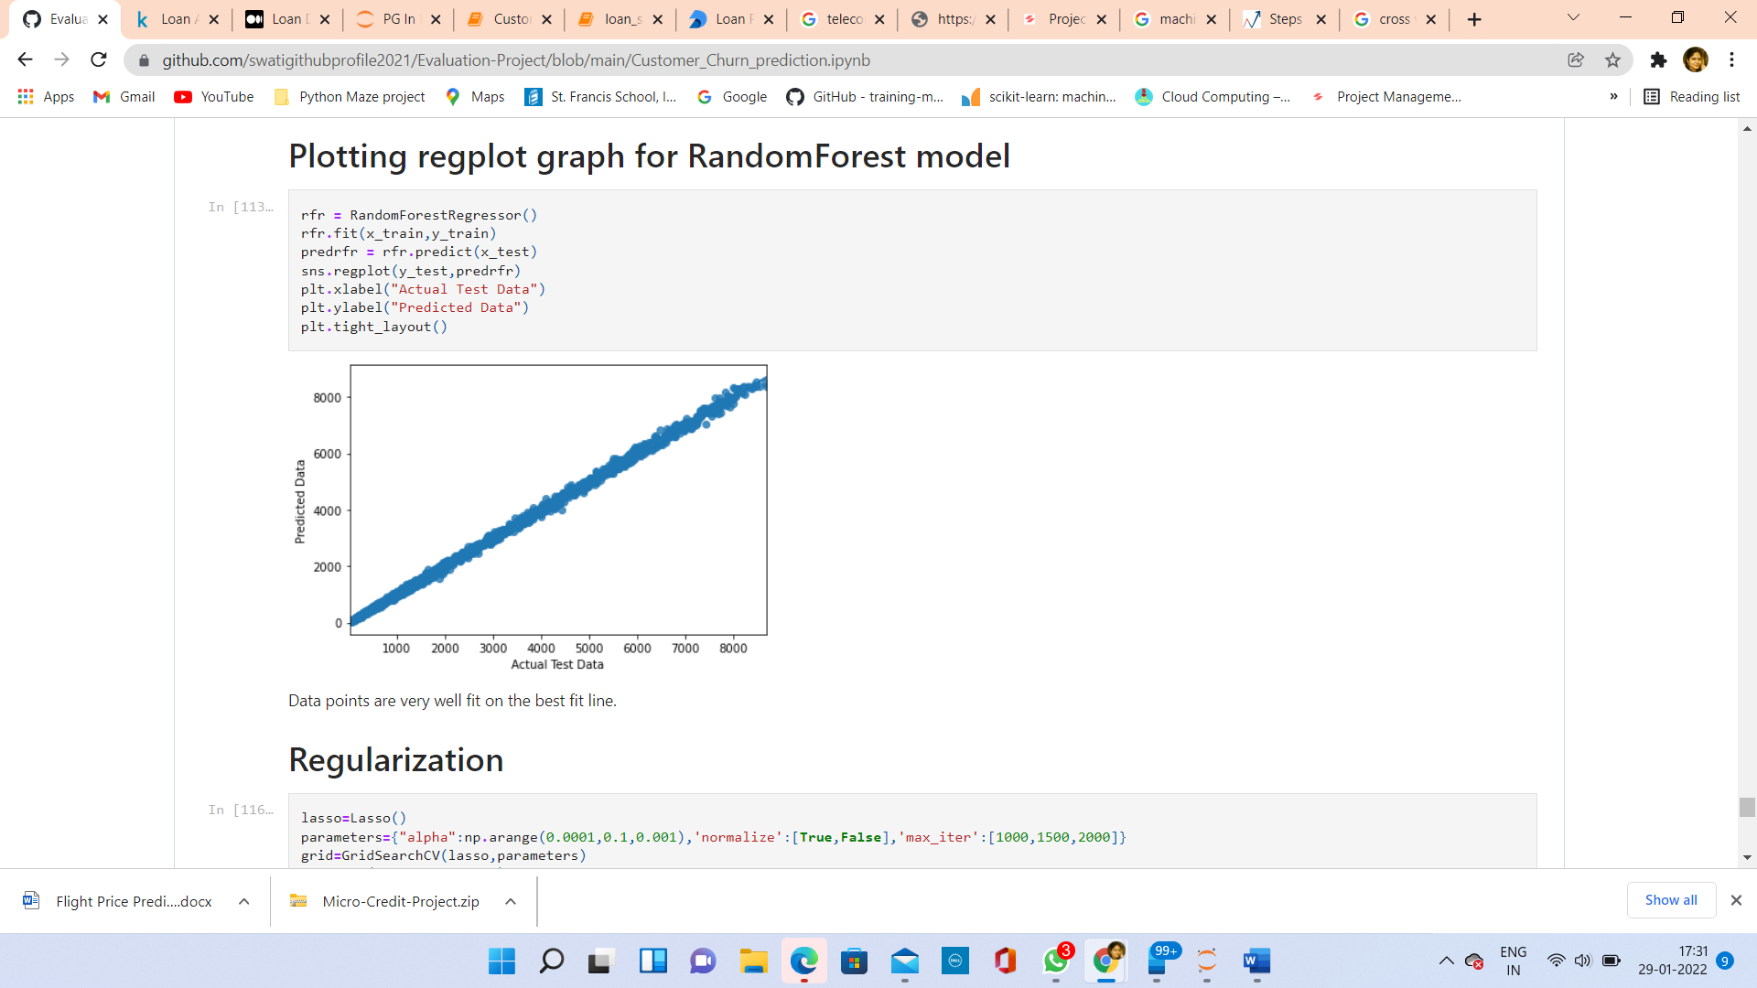

Data points are very well fit on the best fit line.

**Regularization:**

Regularization refers to techniques that are **used to calibrate machine learning models in order to minimize the adjusted loss function and prevent overfitting or underfitting**. Using Regularization, we can fit our machine learning model appropriately on a given test set and hence reduce the errors in it.

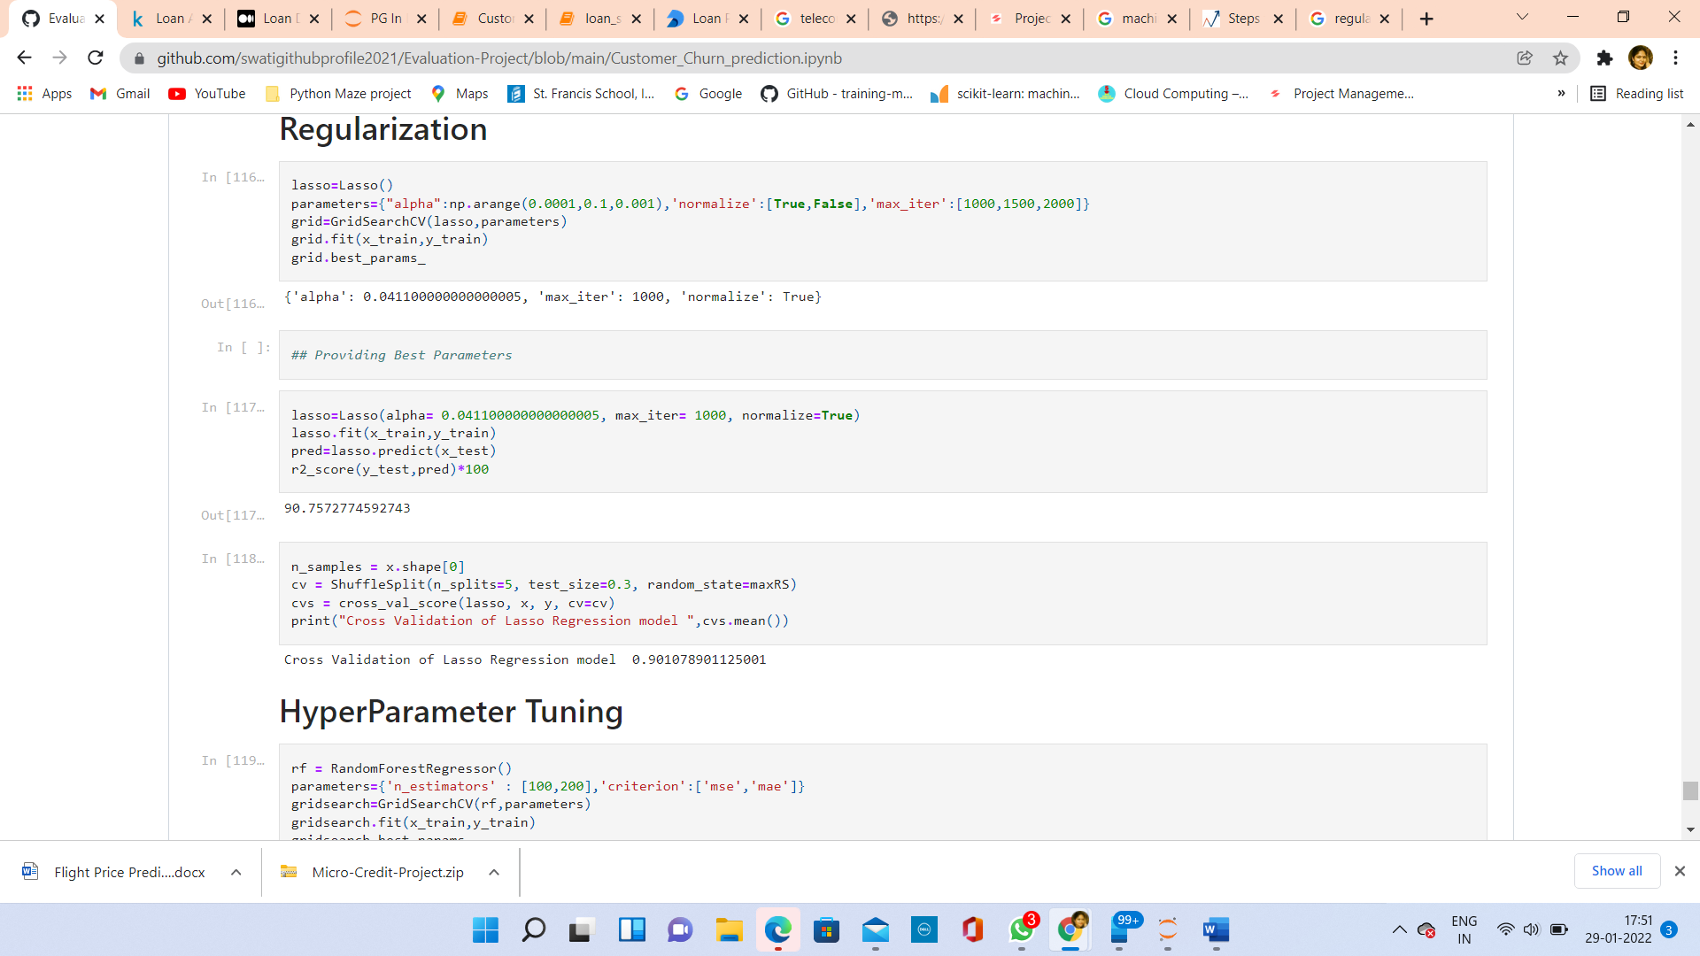

**Hyper Parameter Tuning:**

Hyperparameter tuning is choosing a set of optimal hyperparameters for a learning algorithm. A hyperparameter is a model argument whose value is set before the learning process begins. The key to machine learning algorithms is hyperparameter tuning.

Hyperparameters are **crucial as they control the overall behaviour of a machine learning model**. The ultimate goal is to find an optimal combination of hyperparameters that minimizes a predefined loss function to give better results.

Hyper Parameter tuning has been done for Random Forest Regressor model and Parameters are:

* 1. n_estimators: The number of trees in the forest. Default is 100.
  2. criterion:squared_error, absolute_error, poisson

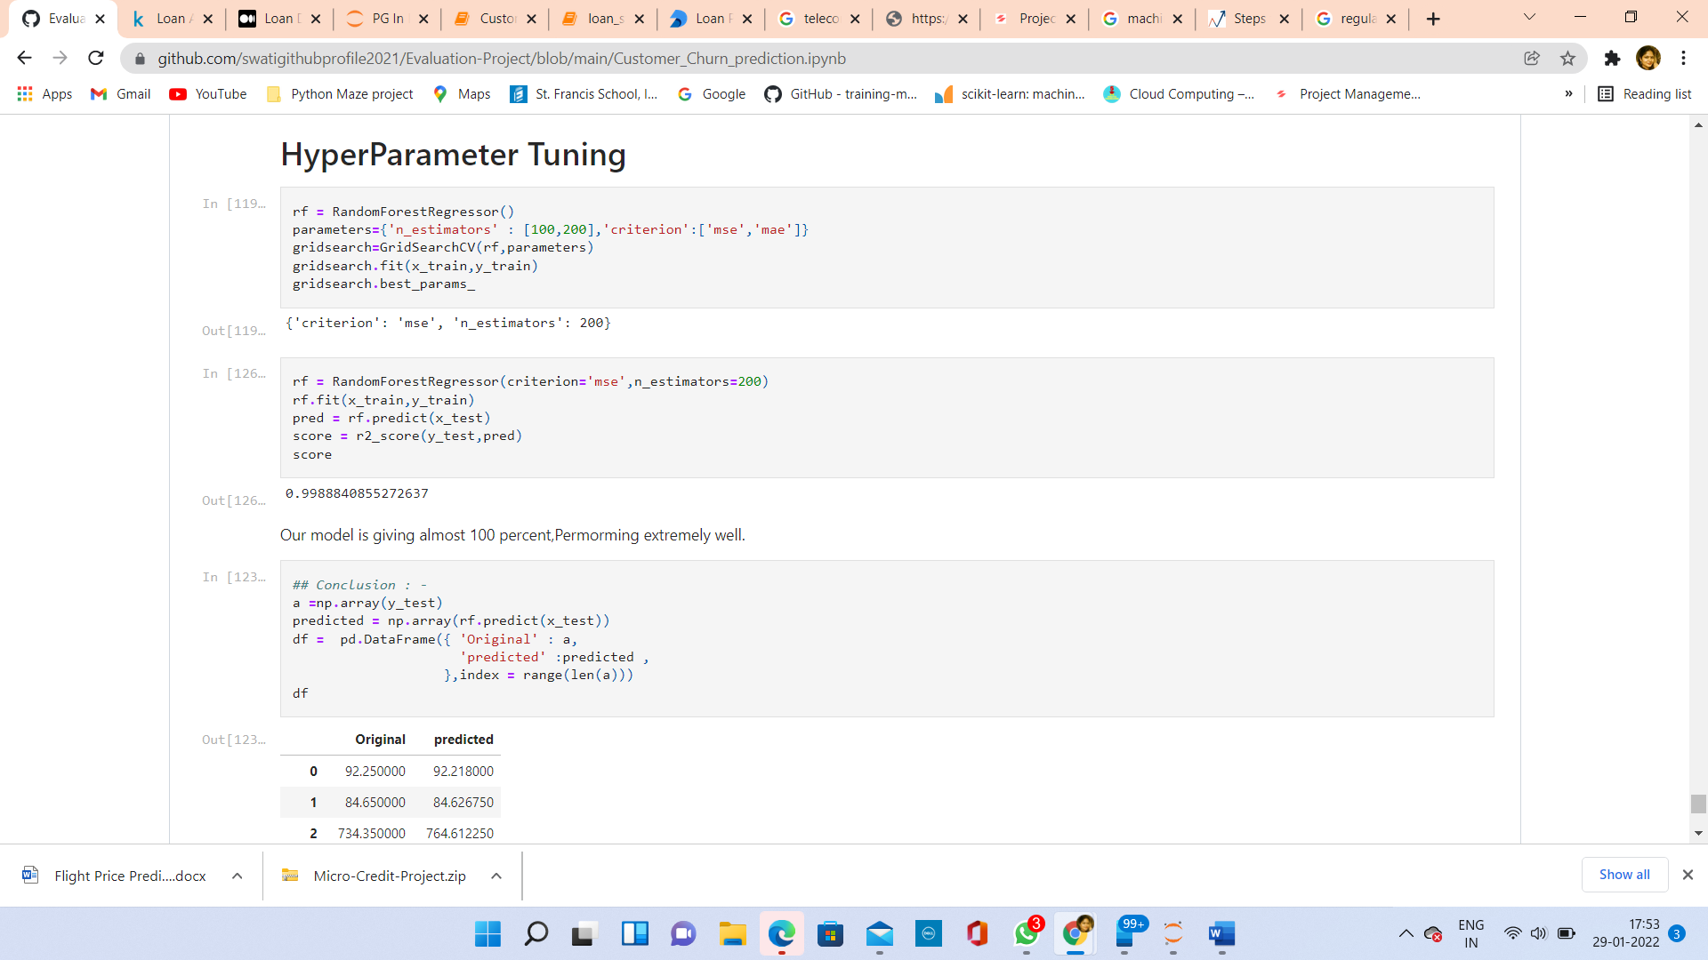

**Conclusion:**

Total charges predicted by my model is almost equal to Original.

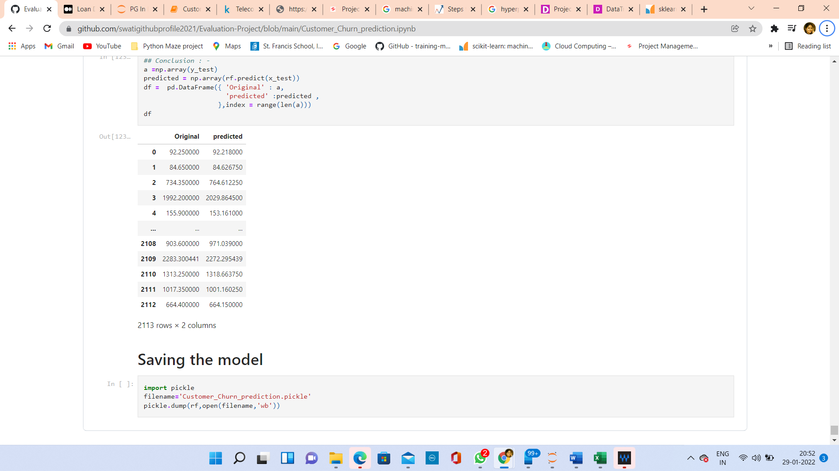

**Saving the Model:**

